1. **INTRODUCTION**

**1.1 Project Summary**

The "Company Management System" has been developed to override the problems prevailing in the practicing manual system. This software is supported to eliminate and, in some cases, reduce the hardships faced by this existing system.

Moreover, this system is designed for the particular need of the company to carry out operations in a smooth and effective manner. The application is reduced as much as possible to avoid errors while entering the data. It also provides error message while entering invalid data. No formal knowledge is needed for the user to use this system. Thus, by this all it proves it is user-friendly. Company Management System, as described above, can lead to error free, secure, reliable and fast management system. It can assist the user to concentrate on their other activities rather to concentrate on the record keeping.

Thus, it will help organization in better utilization of resources. Every organization, whether big or small, has challenges to overcome and managing the information of Leave, Employee, Expense, Leave Type, Project, Clients, Task. Every Company Management System has different Employee needs. therefore, we design exclusive Company Management System that are adapted to your managerial requirements. This is designed to assist in strategic planning, and will help you ensure that your organization is equipped with the right level of information and details for your future goals.

Also, for those busy executive who are always on the go, our systems come with remote access features, which will allow you to manage your workforce anytime, at all times. These systems will ultimately allow you to better manage resources.

**1.2 Project Technical Profile**

|  |  |
| --- | --- |
| **Project Title:** | Dream Studio Architecture Ltd. |
| **Definition:** | Architecture, the art and technique of designing and building, as distinguished from the skills associated with construction. |
| **Developed For:** | S.D.J. International College, Vesu, Surat |
| **Project Guide:** | Prof. Jaimini Patel |
| **Front End:** | HTML, CSS, Bootstrap, JavaScript |
| **Scripting Language:** | PHP, JavaScript |
| **Back End:** | My SQL, PHP |
| **Operating System:** | Window, Mac OS |
| **Designing Tools:** | Vs code, PHP My Admin, Bootstrap |
| **Tools used for ERD & DFD:** | Wondershare EdrawMax, Xmind |
| **Submitted By:** | 1. Chintan Bhimani A. 2. Pratiksha Chopda B. 3. Jasmin Bhanderi V. |

1. **SCOPES & PLANNING**

2.1 Requirement Analysis

Requirement analysis for a Company Management System would involve identifying the necessary features and functions that the system should have in order to effectively manage employee data and workflows. Here are some key requirements that could be considered:

Employee Information Management: The system should allow for easy storage, retrieval and modification of employee information such as name, contact details, department, job title, employment history, etc.

Leave Management: The system should allow employees to record their leaves, with a dashboard that displays this information to the management.

Benefits: The system should be able to calculate employee salaries based on attendance and other relevant factors. It should also have features for managing employee benefits such as health insurance, retirement plans, etc.

Performance Management: The system should allow managers to set goals, provide feedback, and conduct performance reviews for employees. It should also track and report on employee progress towards their goals.

Training and Development: The system should facilitate employee training and development by providing access to relevant courses, workshops, and other resources.

Communication: The system should enable communication between employees and managers, as well as among employees themselves. It should allow for messaging, file sharing, and other collaborative features.

Security: The system should have strong security measures to protect sensitive employee data. It should also be able to comply with relevant data protection regulations.

Reporting and Analytics: The system should have robust reporting and analytics features to provide insights into employee data, such as attendance trends, performance metrics, and other key performance indicators.

Mobile Compatibility: The system should be accessible on mobile devices, allowing employees and managers to access information and perform tasks on the go.

User-Friendly Interface: The system should have a user-friendly interface that is easy to navigate and use, with clear instructions and helpful features to support users.

**2.2 Technology Details**

* **Hardware Requirements:**

|  |  |  |
| --- | --- | --- |
| Processor | : | Intel(R) Pentium i3 CPU @ 2.30GHz |
| Memory | : | 6 GB |
| Hard Disk | : | 256 GB or Higher |

* **Software Requirements:**

|  |  |  |
| --- | --- | --- |
| Operating System | : | Microsoft Windows 10/11 |
| Front End | : | React.js, HTML |
| Backend | : | Node.js, Express.js |
| Input Device | : | Keyboard, Mouse |
| Output Device | : | Screen |
| Browser | : | All Browser Supported |

1. **DESIGNING**

**3.1 Data Flow Diagram**

**0 Level DFD**

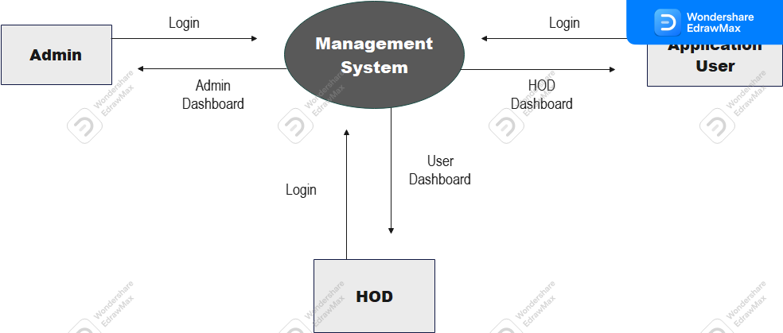

**1st level DFD of Admin Part-1**

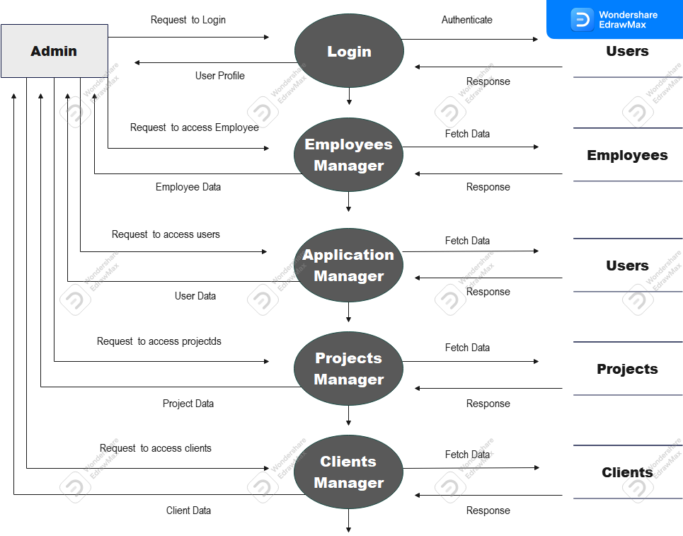

**1st level DFD of Admin Part-2**

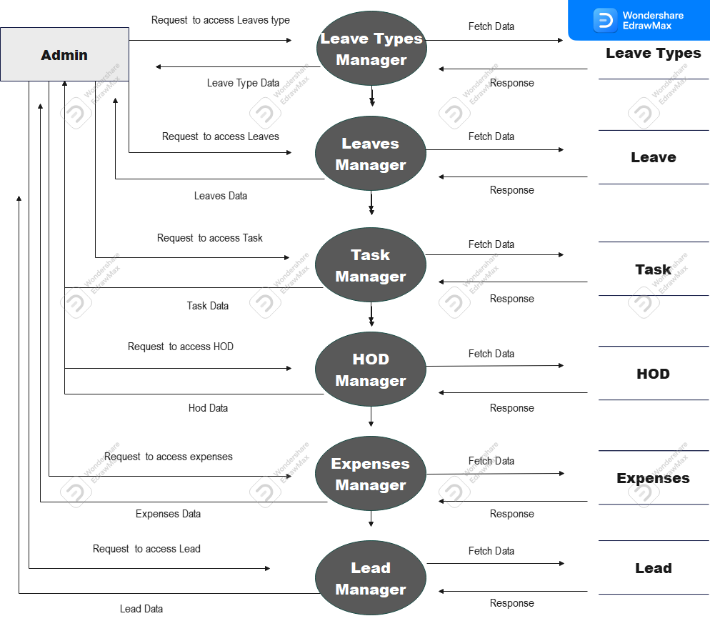

**1st level DFD of HOD Part-1**

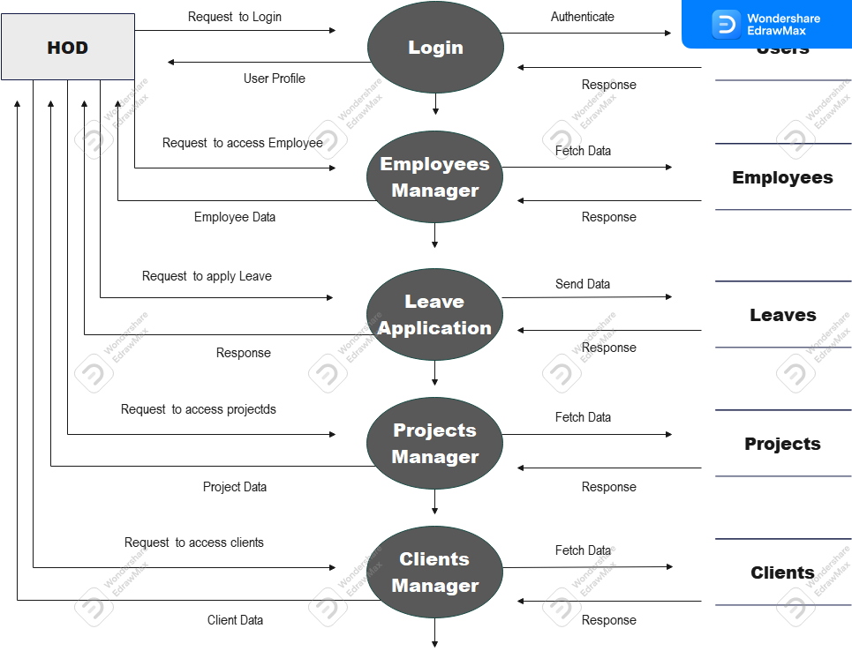

**1st level DFD of HOD Part-2**

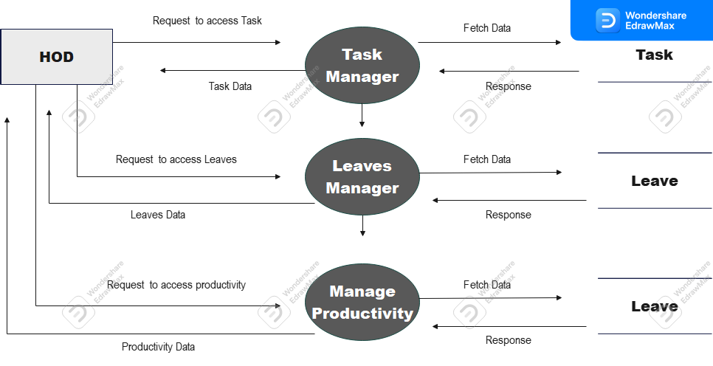

**1st level DFD of Employee**

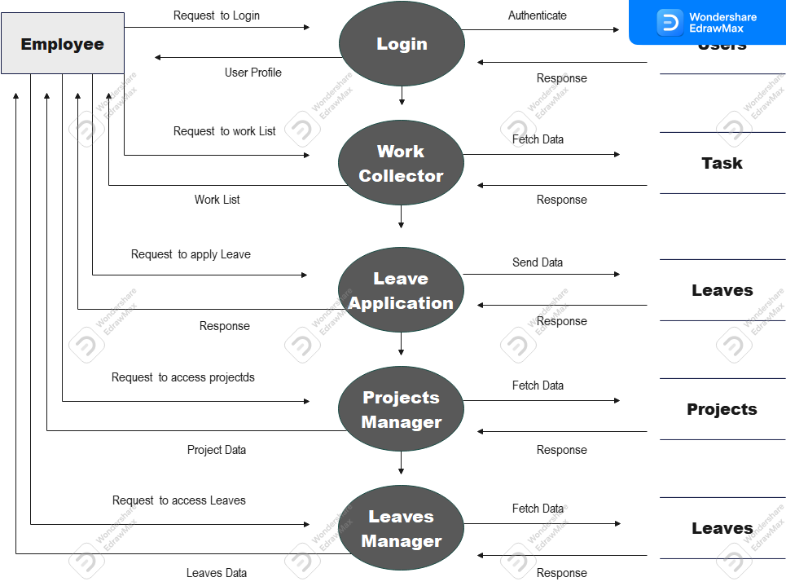

**2nd level DFD of Admin – Application Users**

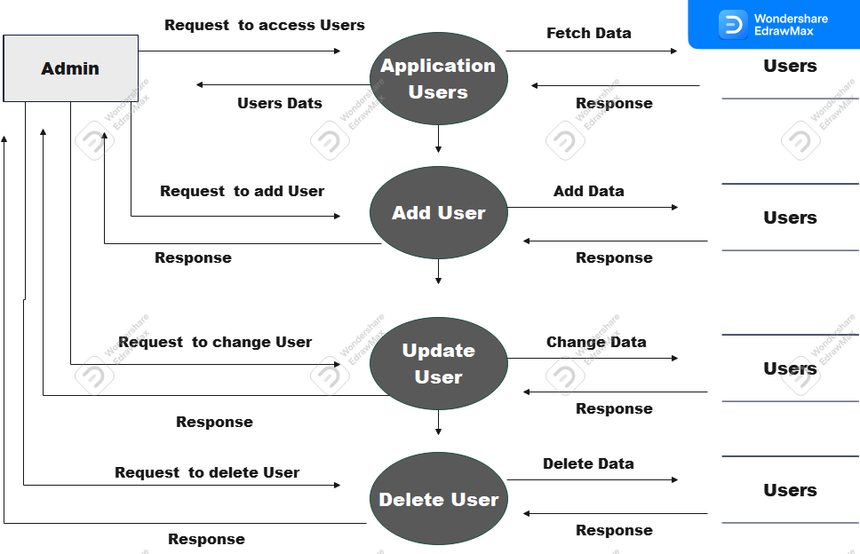

**2nd level DFD of Admin – Task Management**

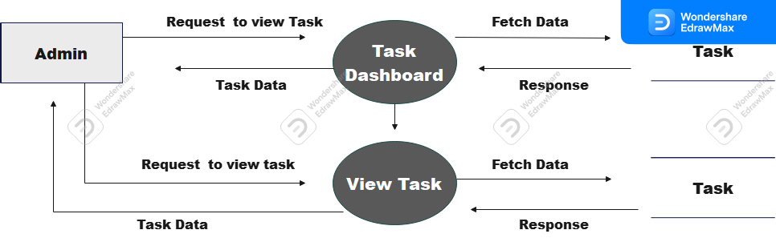

**2nd level DFD of Admin – Project Management**

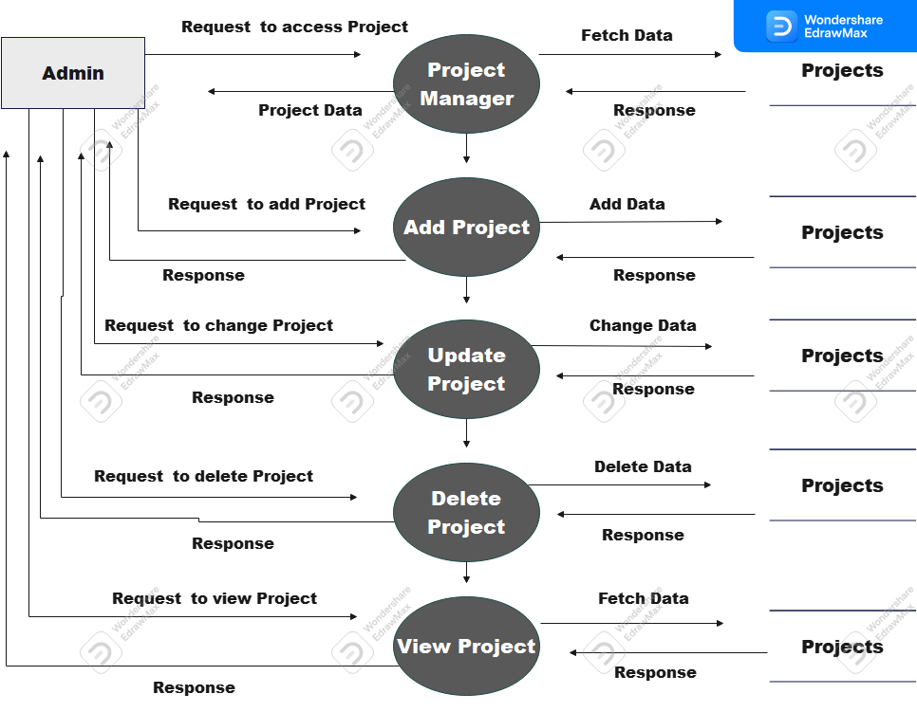

**2nd level DFD of Admin – Profile**

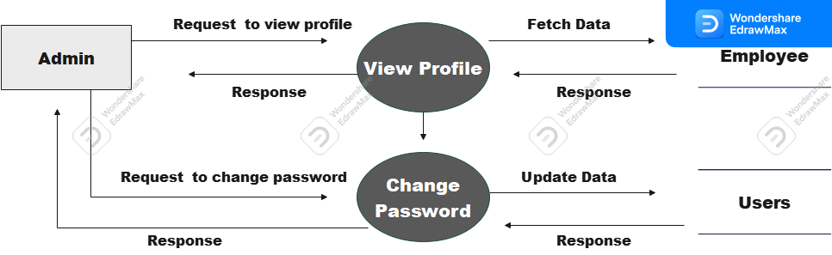

**2nd level DFD of Admin – Leave Types**

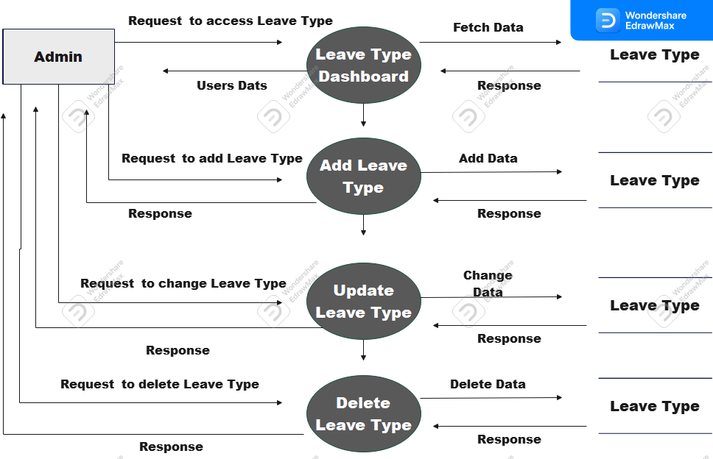

**2nd level DFD of Admin – Leave Management**

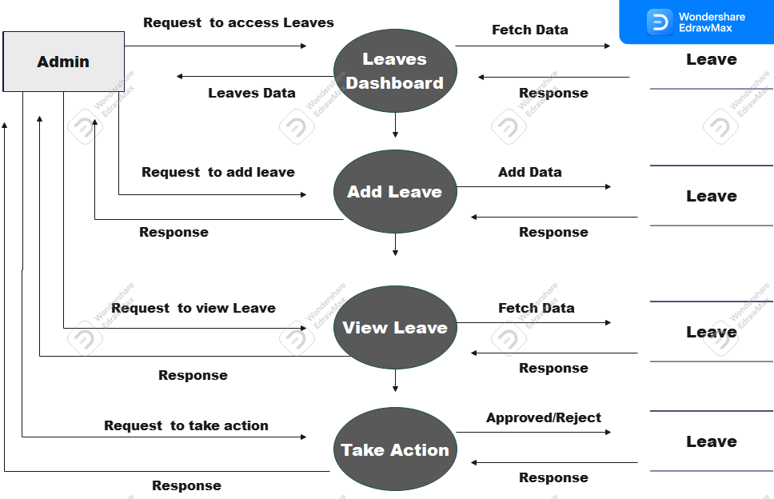

**2nd level DFD of Admin –Lead Management**

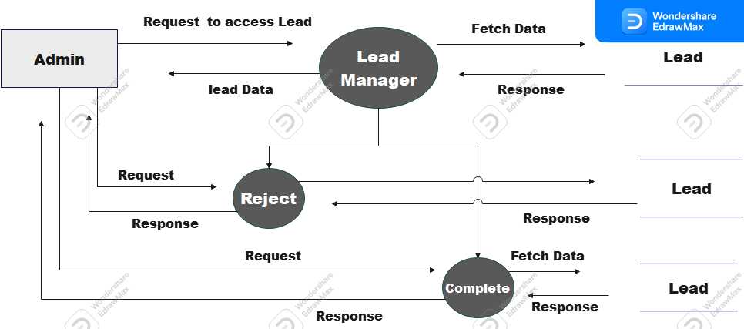

**2nd level DFD of Admin – Expense Management**

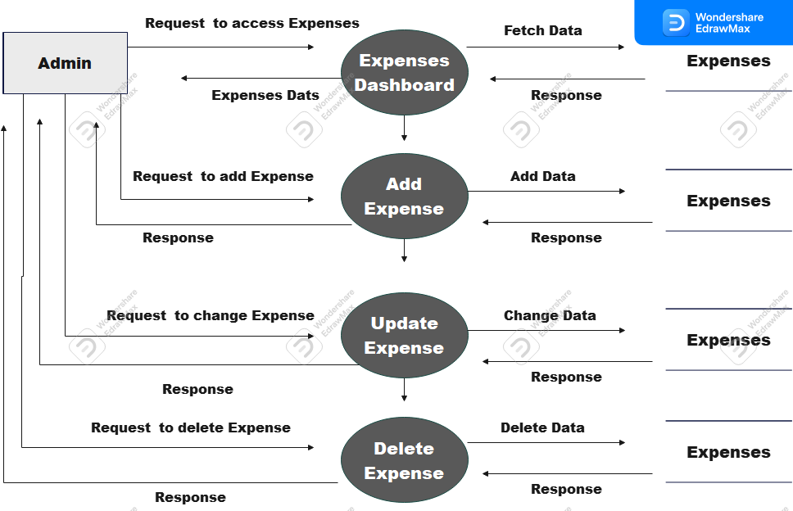

**2nd level DFD of Admin – Client Management**

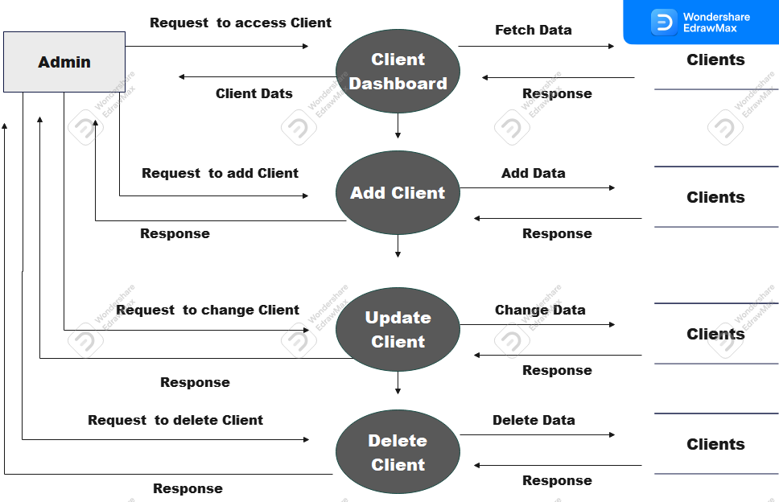

**2nd level DFD of Admin –Employee Management**

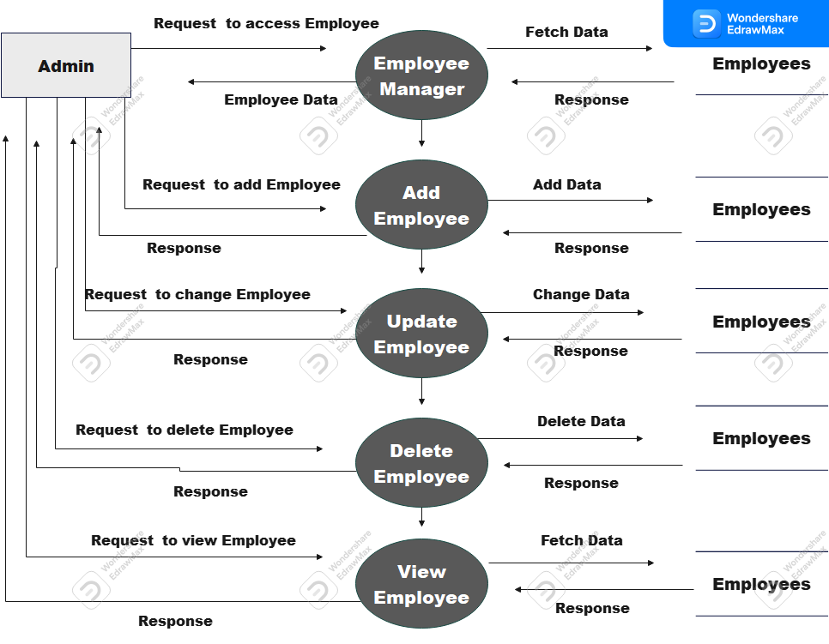

**2nd level DFD of HOD –Project Management**

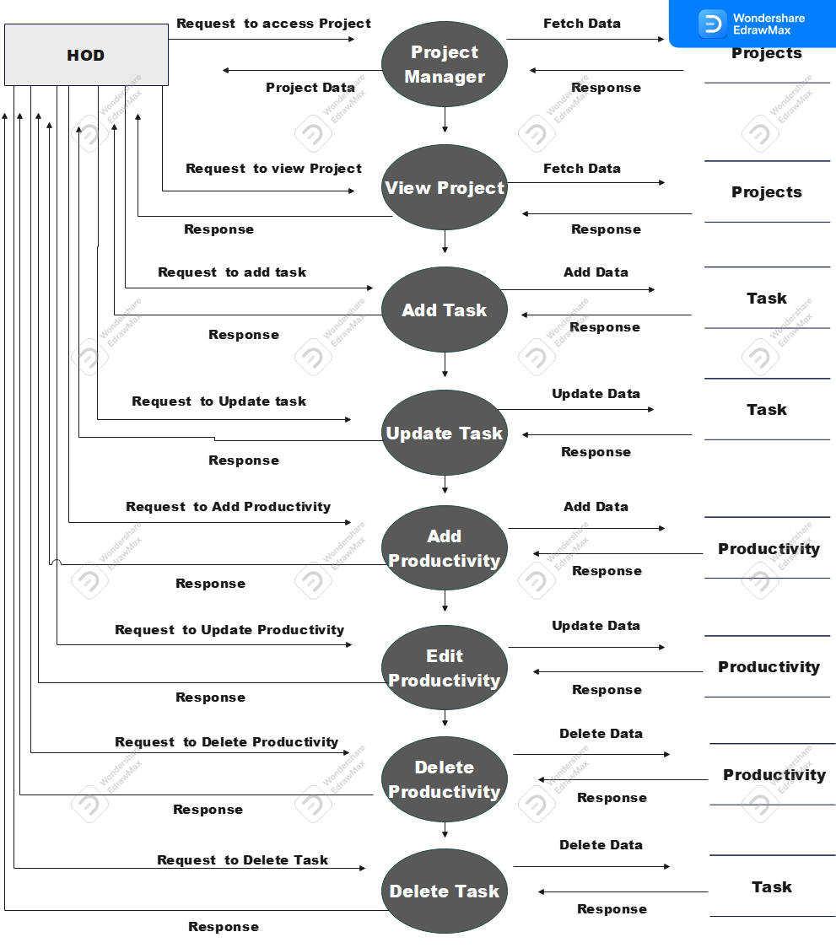

**2nd level DFD of HOD –Profile**

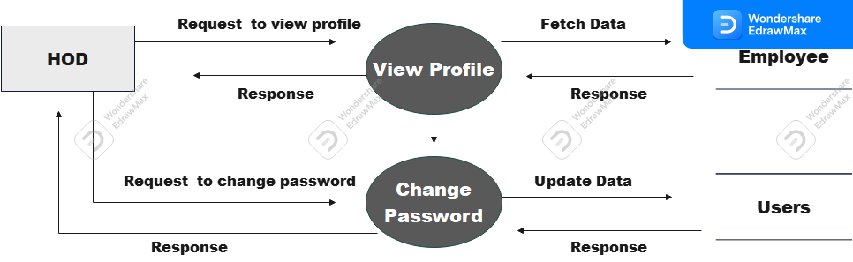

**2nd level DFD of HOD –Leave Management**

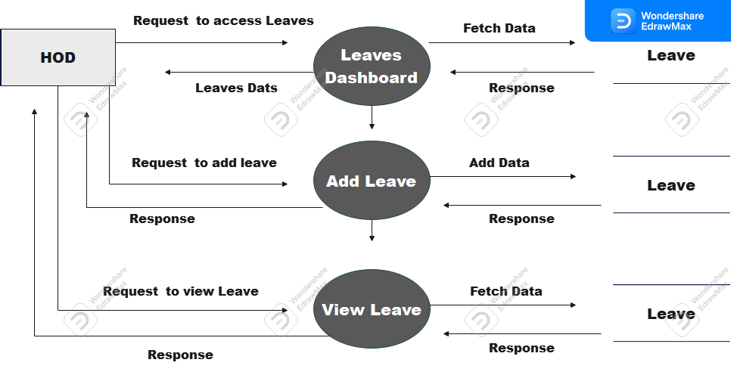

**2nd level DFD of HOD –Employee Management**

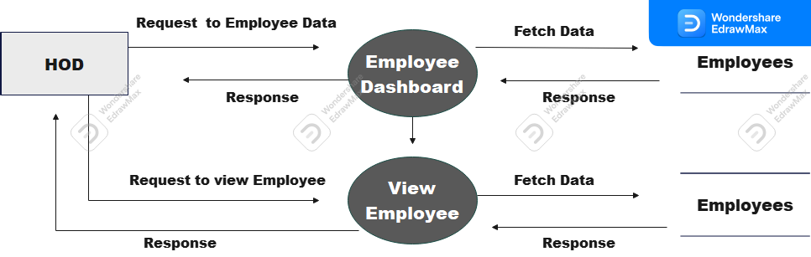

**2nd level DFD of HOD –Client Management**

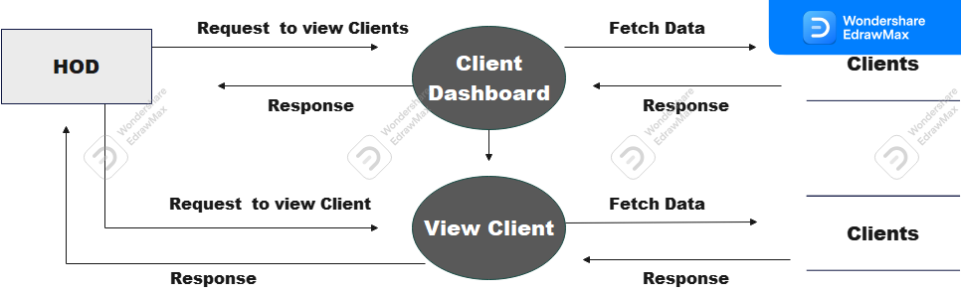

**2nd level DFD of Employee –Project Management**

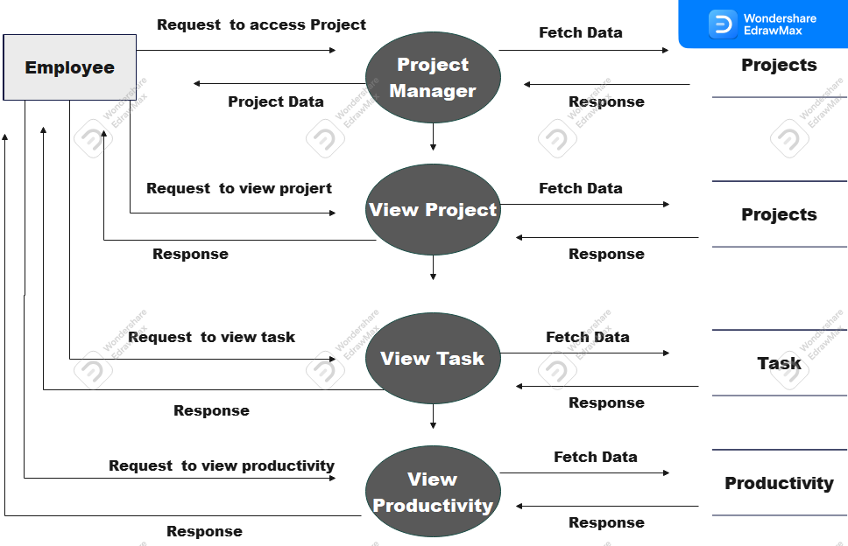

**2nd level DFD of Employee –Work Collector**

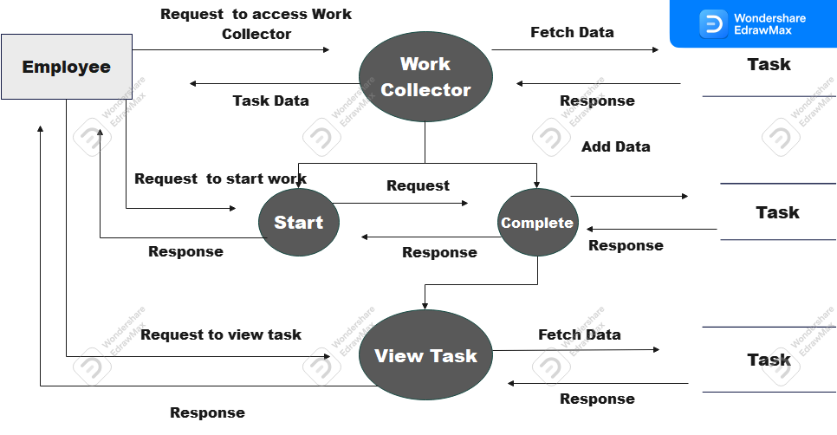

**2nd level DFD of Employee –Profile**

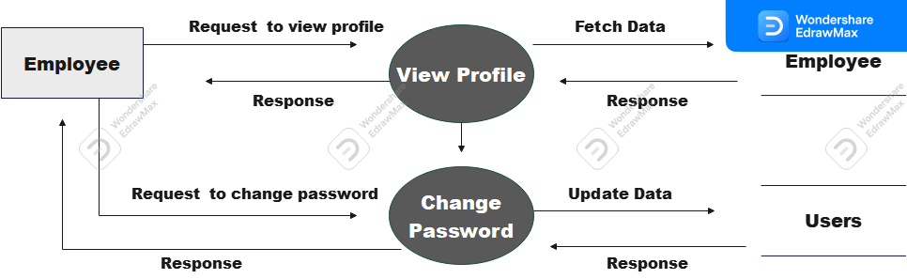

**2nd level DFD of Employee –Leave Management**

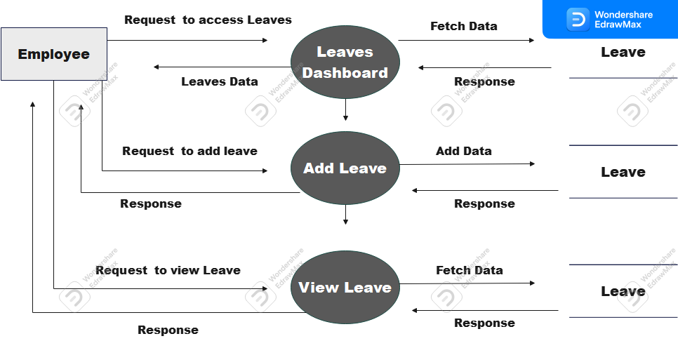

**3.2 Use Case Diagram**

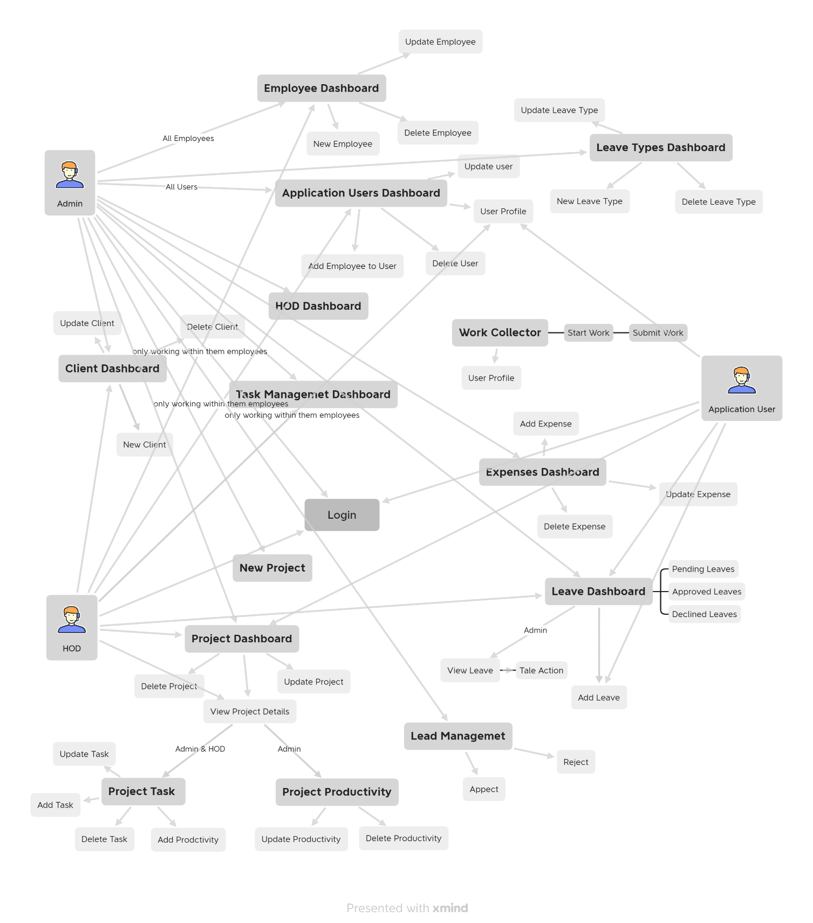

**Use Case Diagram – Admin**

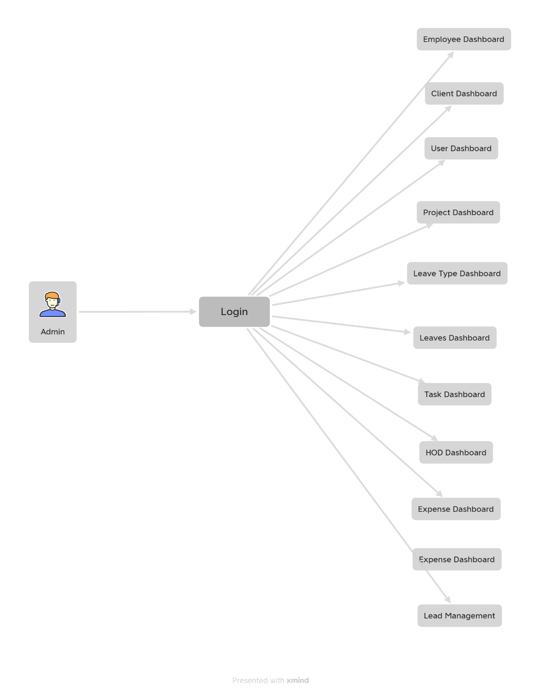

**Use Case Diagram – HOD**

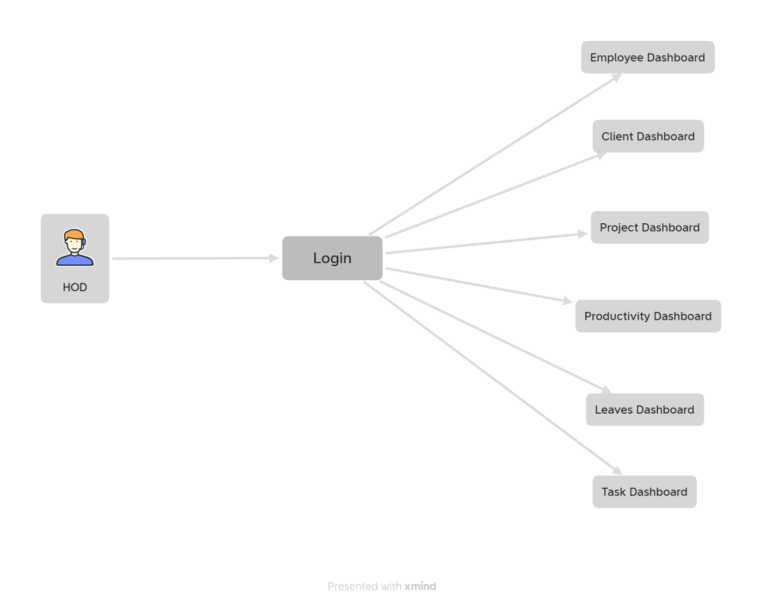

**Use Case Diagram – Employee**

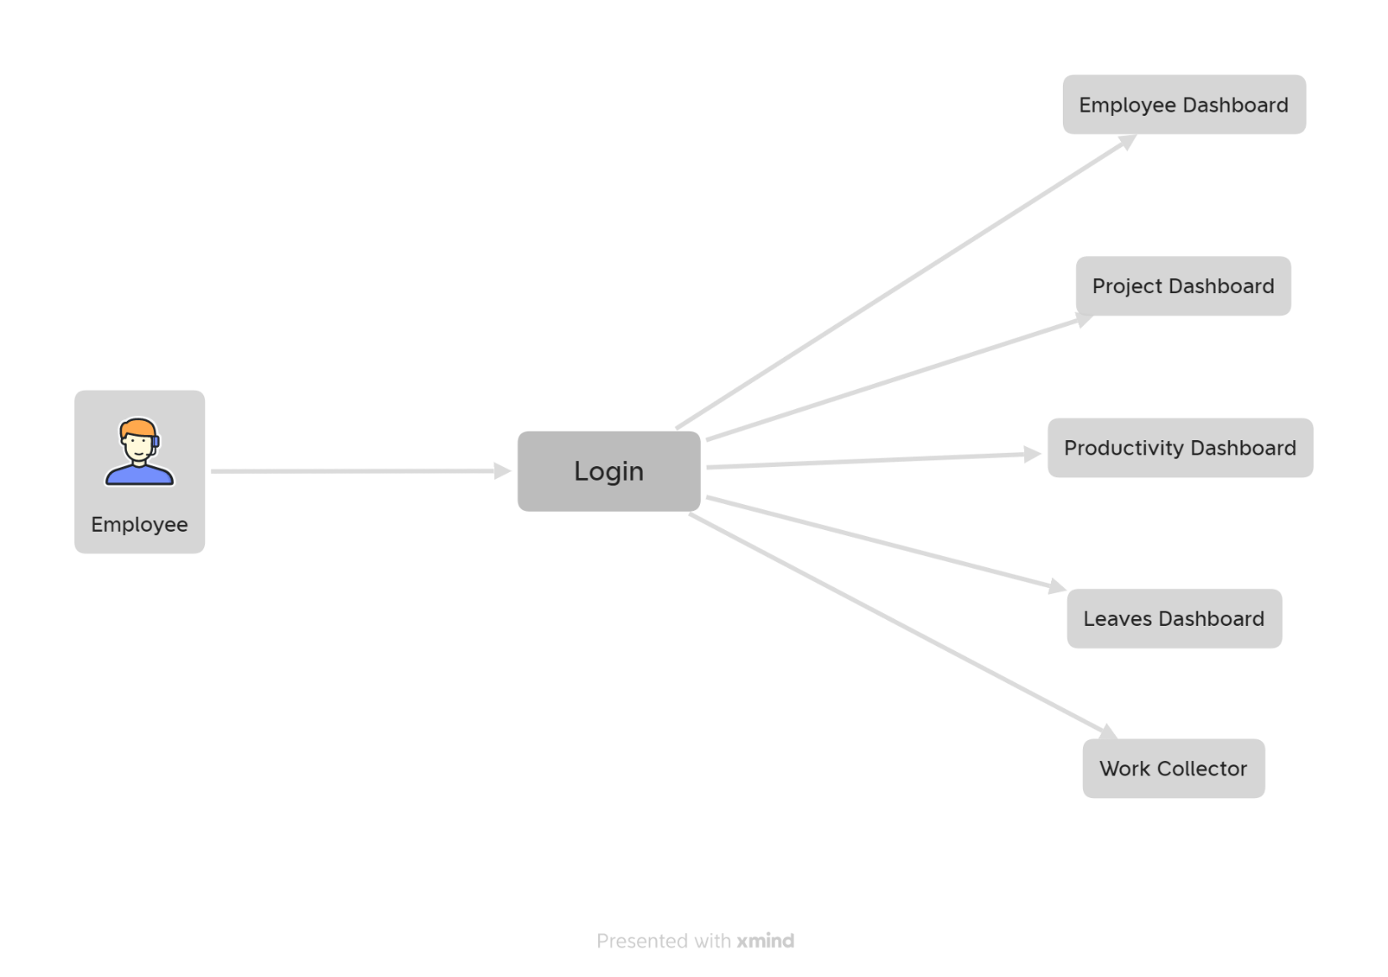

**3.3 ER Diagram**

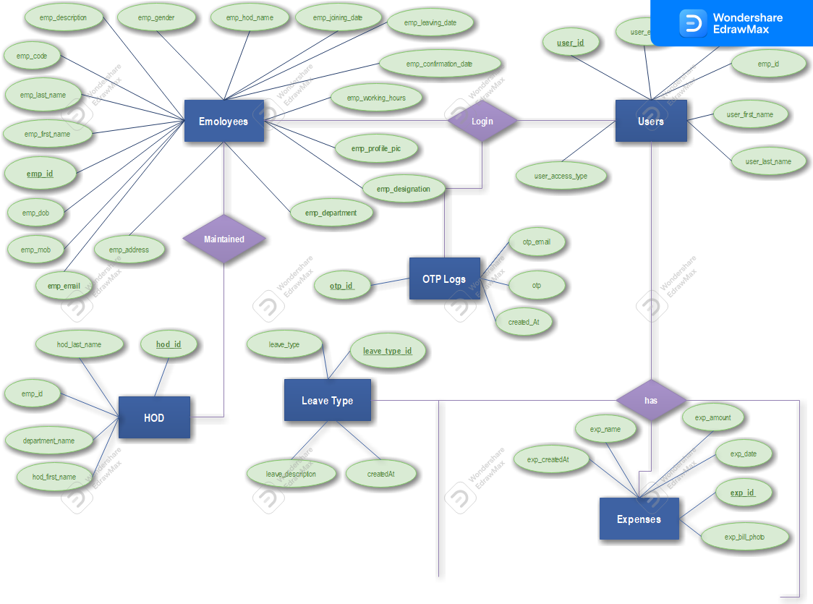

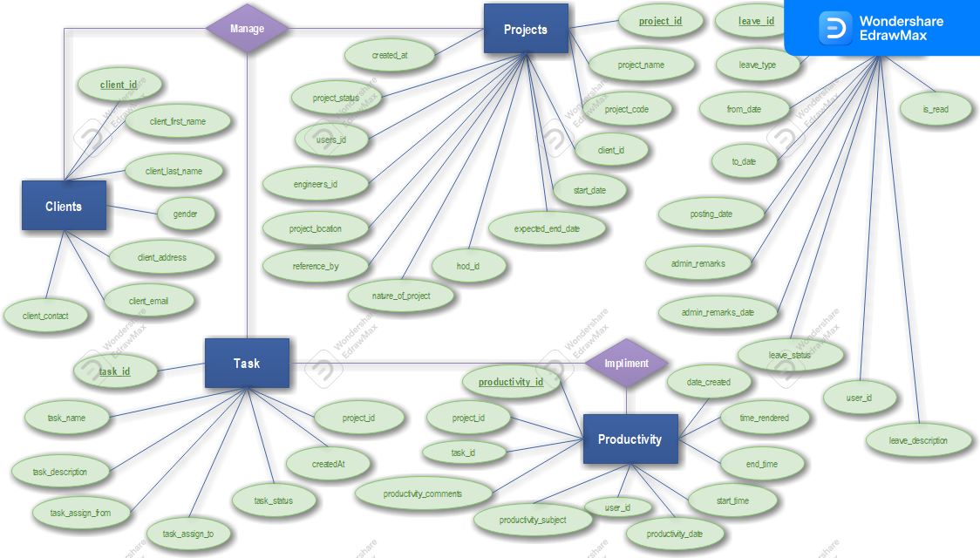

**3.4 Database Design**

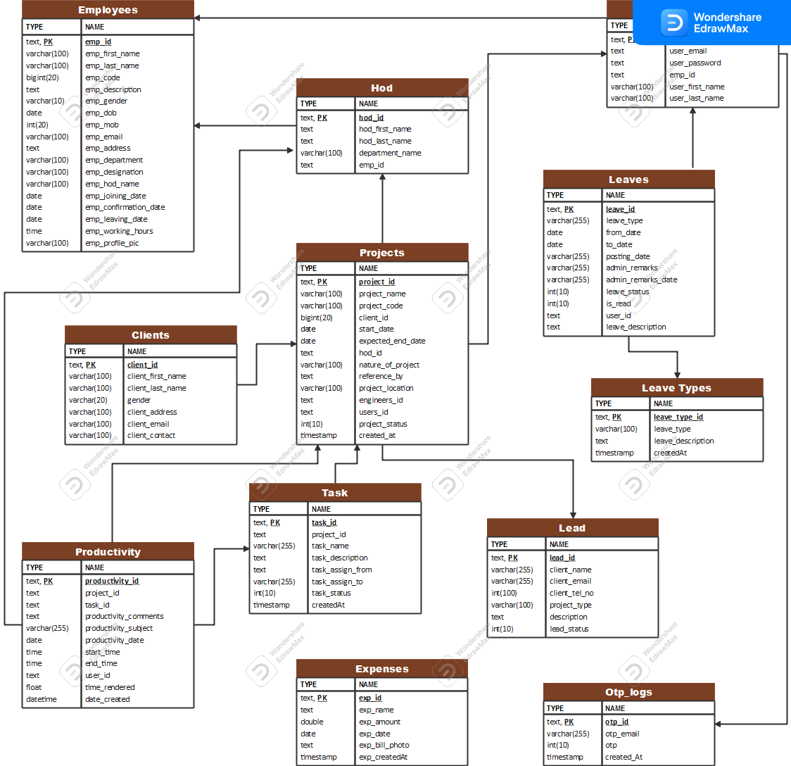

**3.5 Data Dictionary**

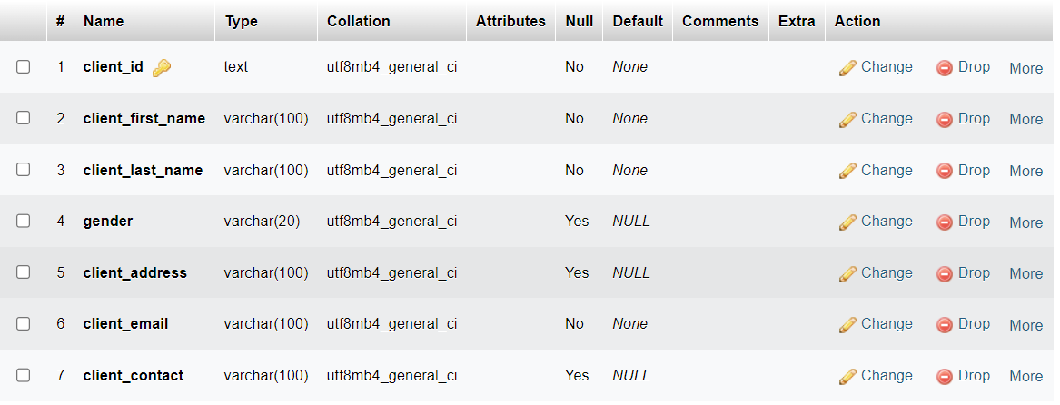

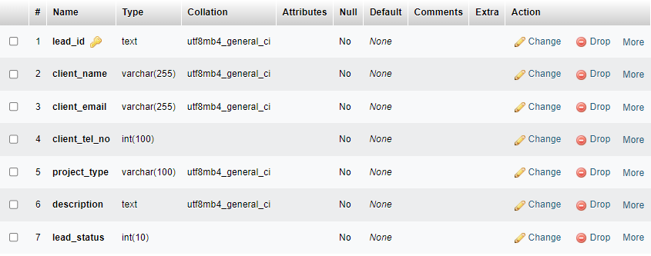

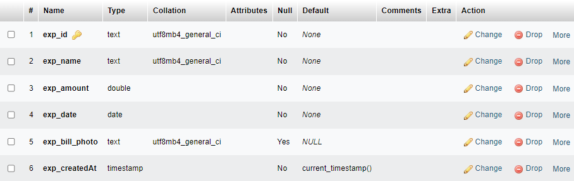

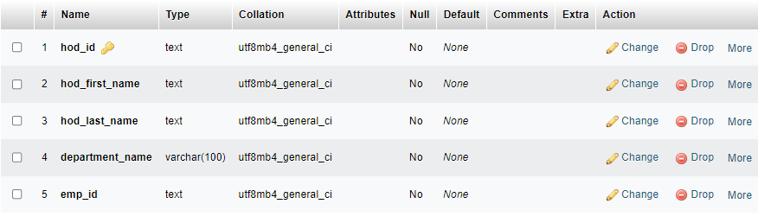

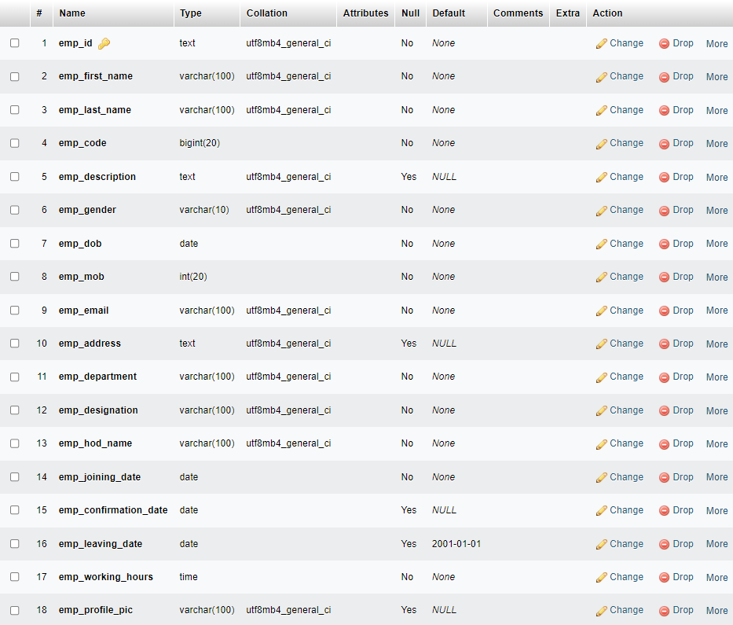

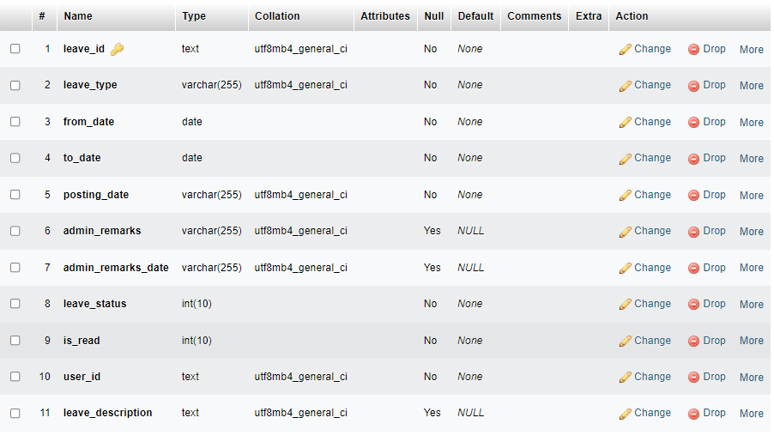

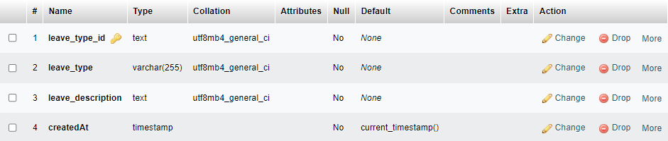

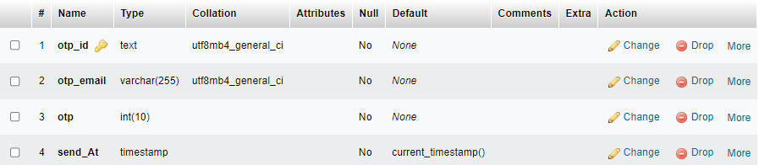

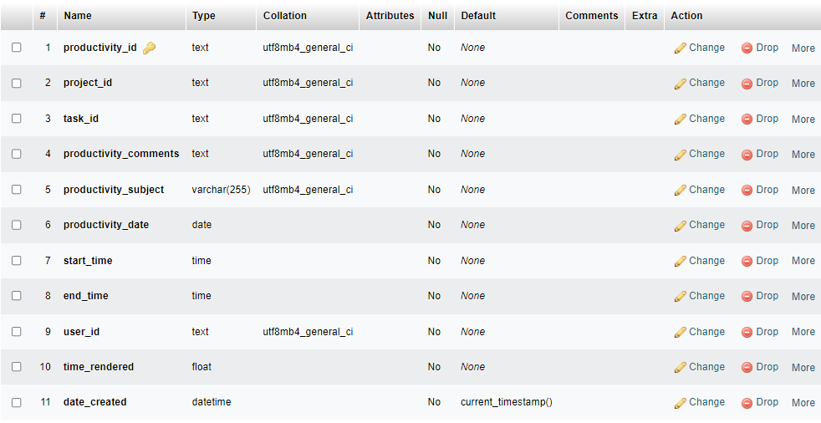

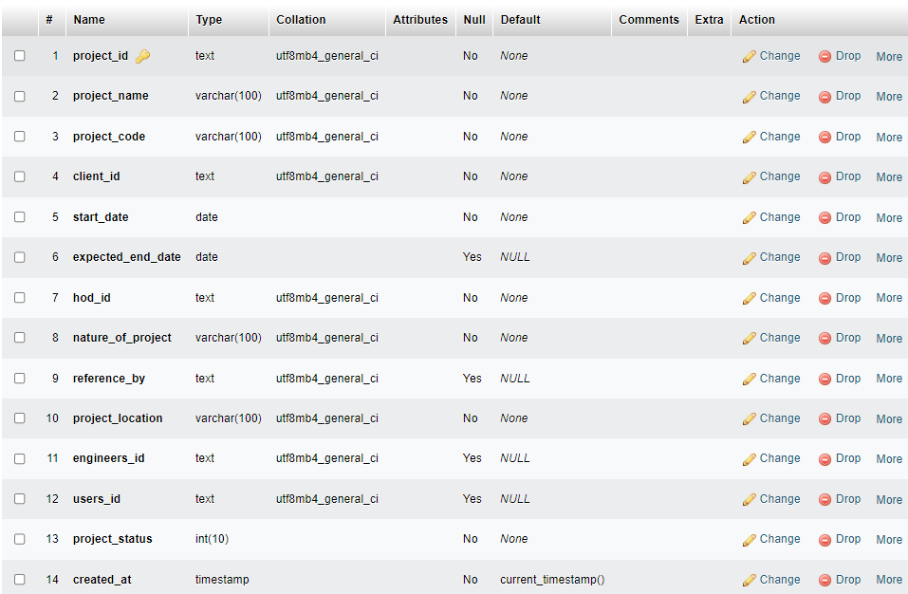

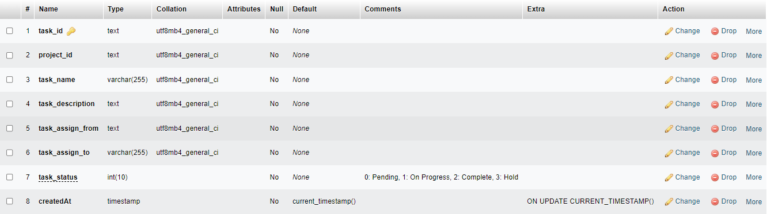

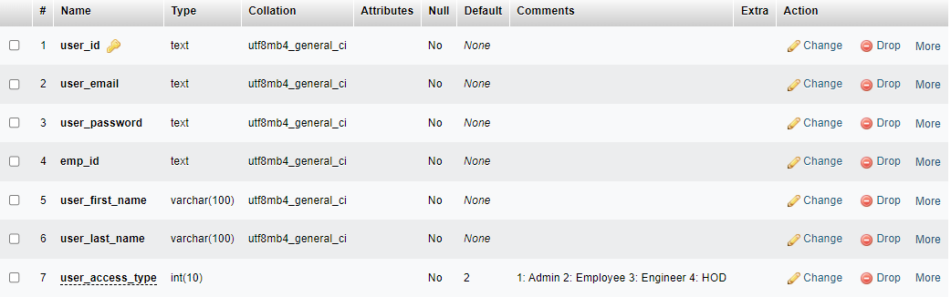

**3.5 User Interface**

**FRONTEN**

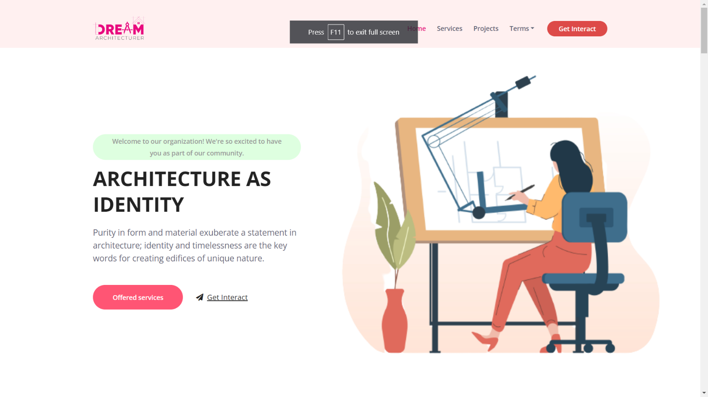

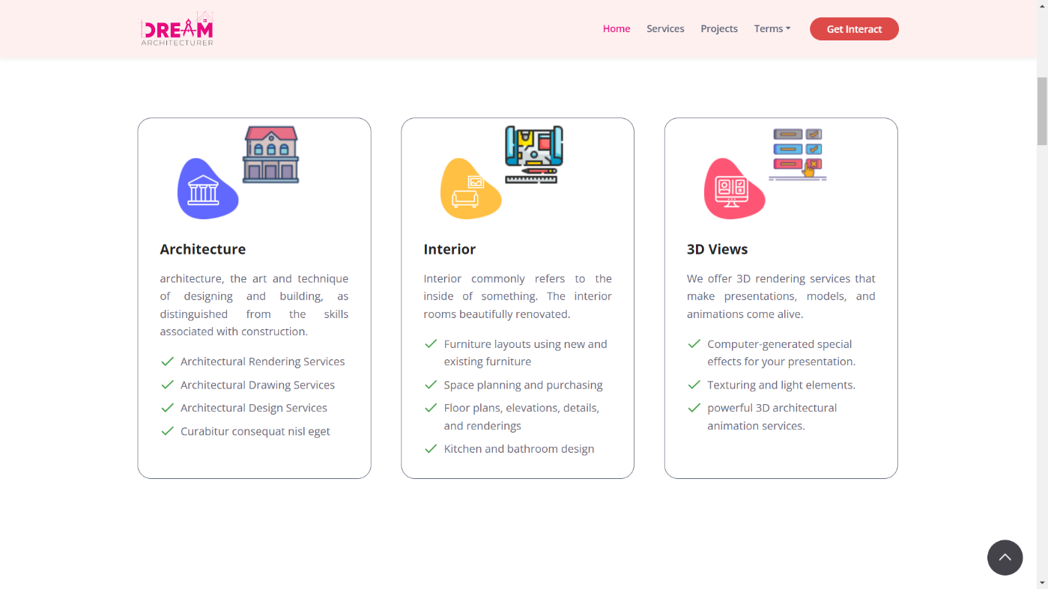

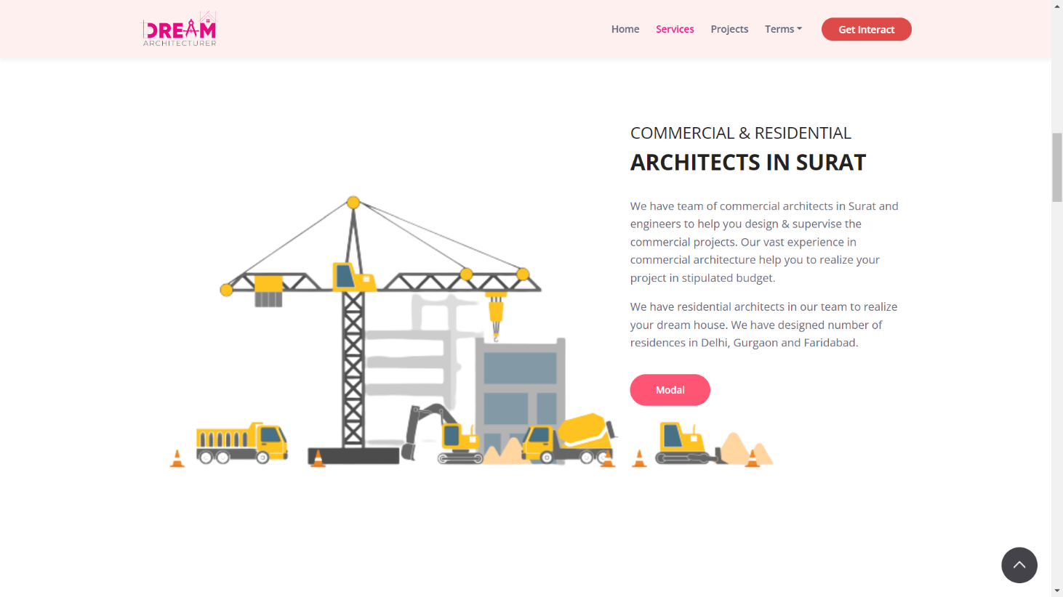

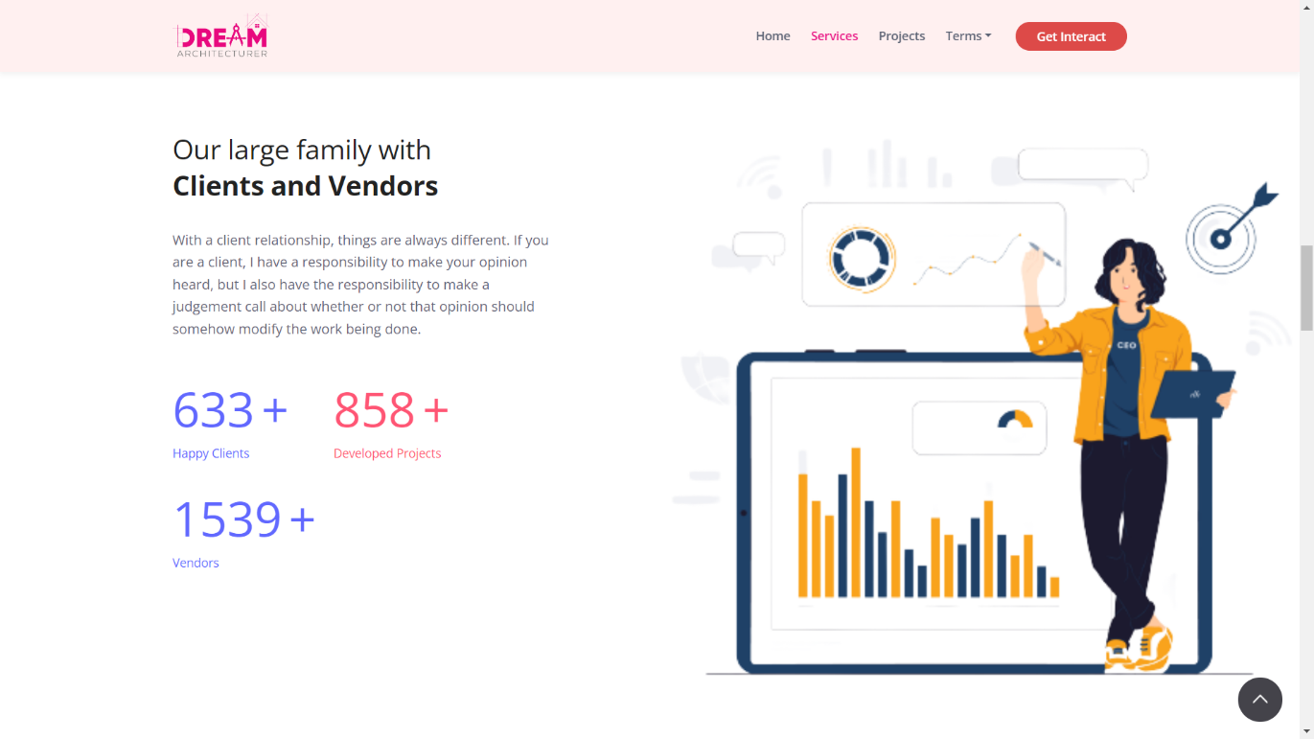



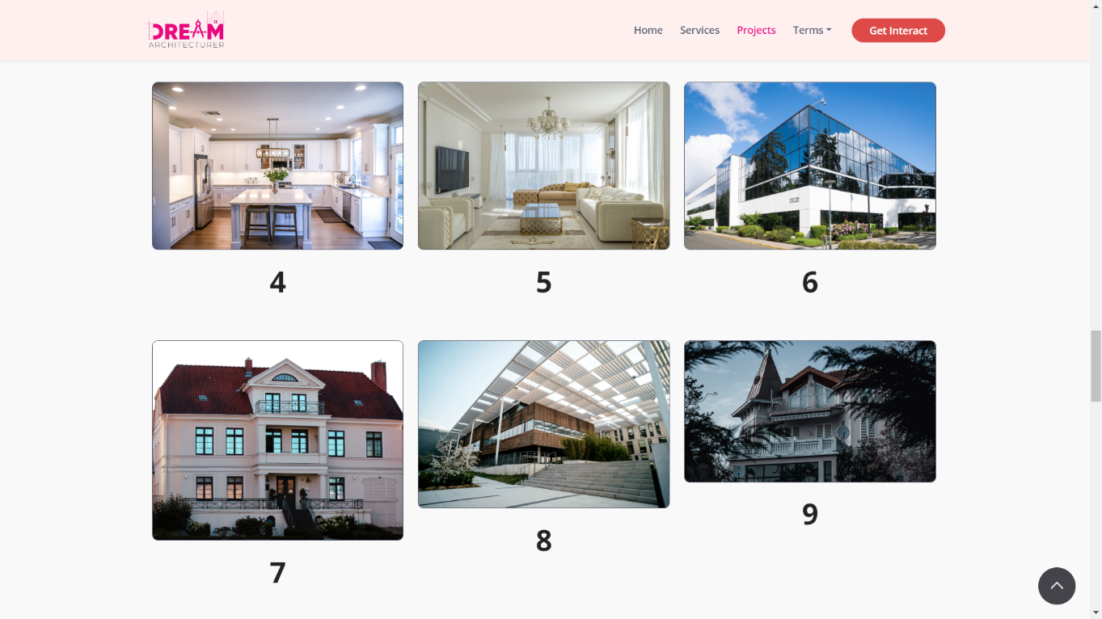

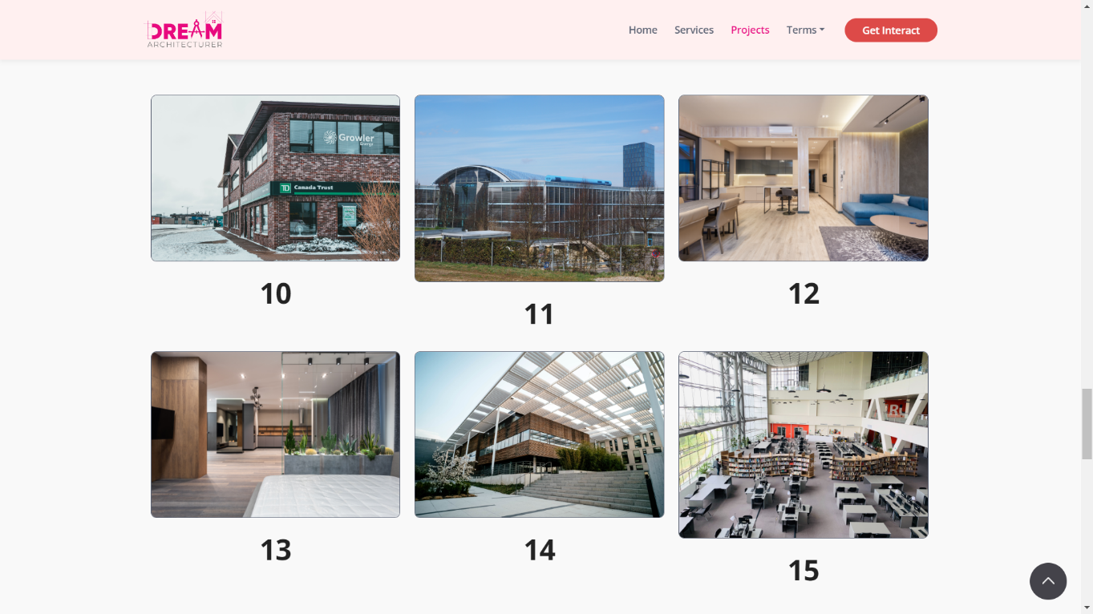

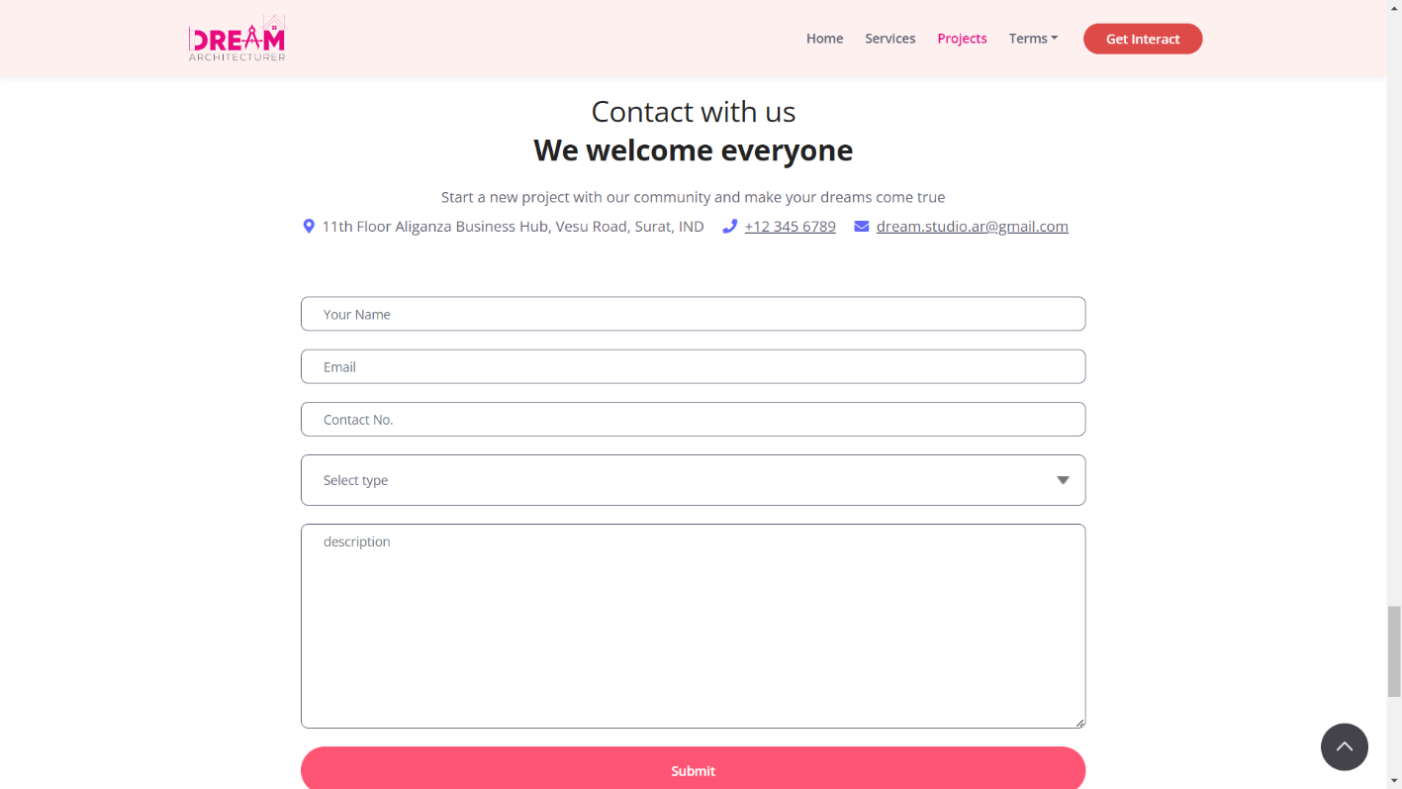

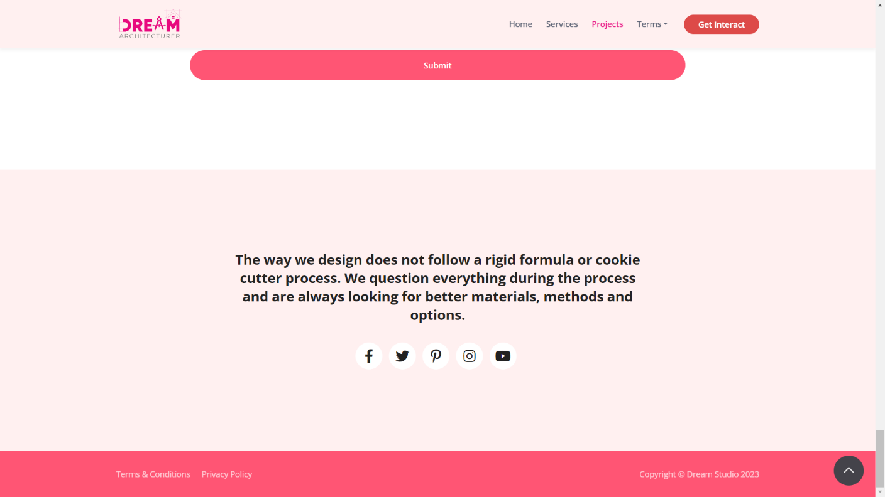

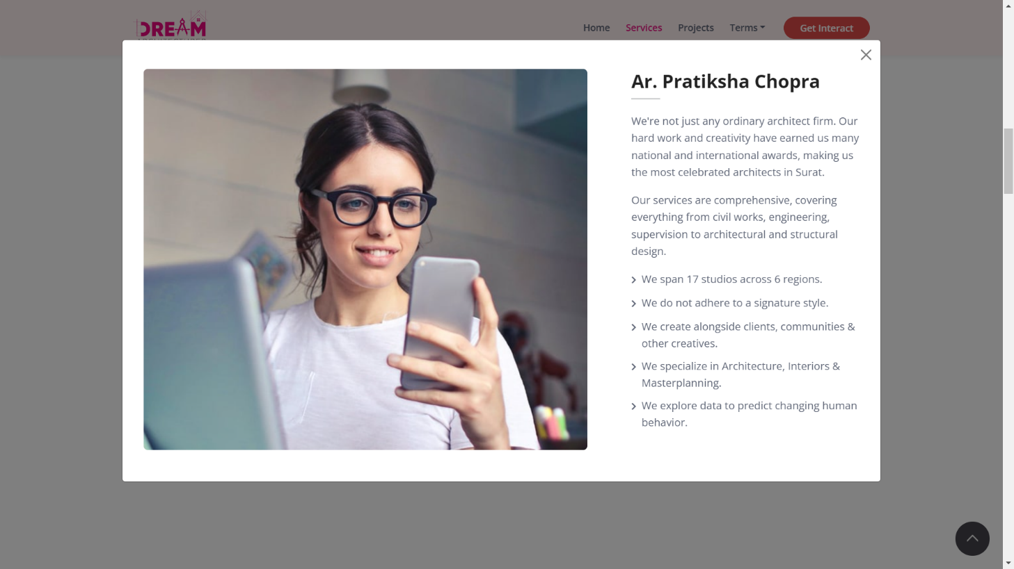

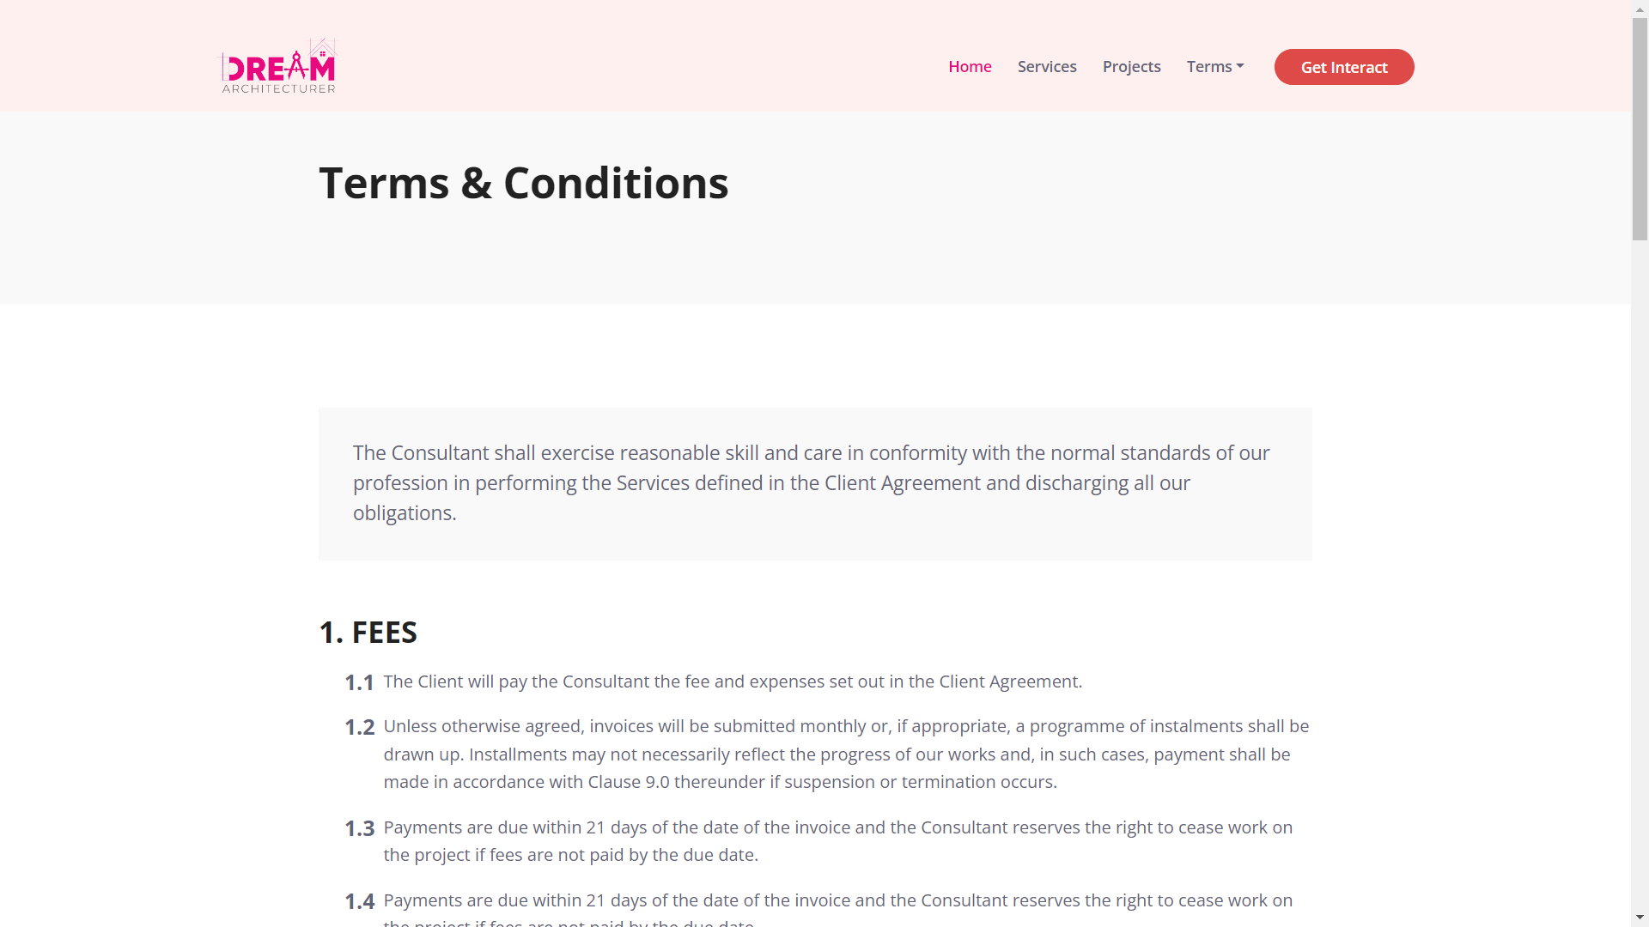

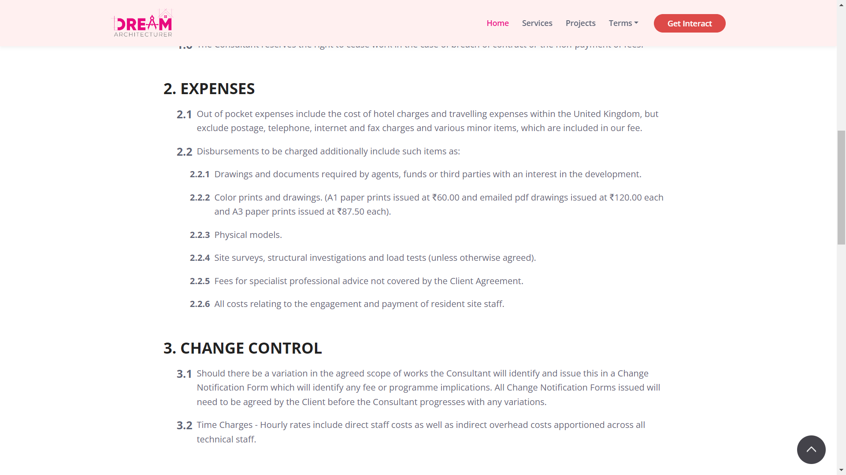

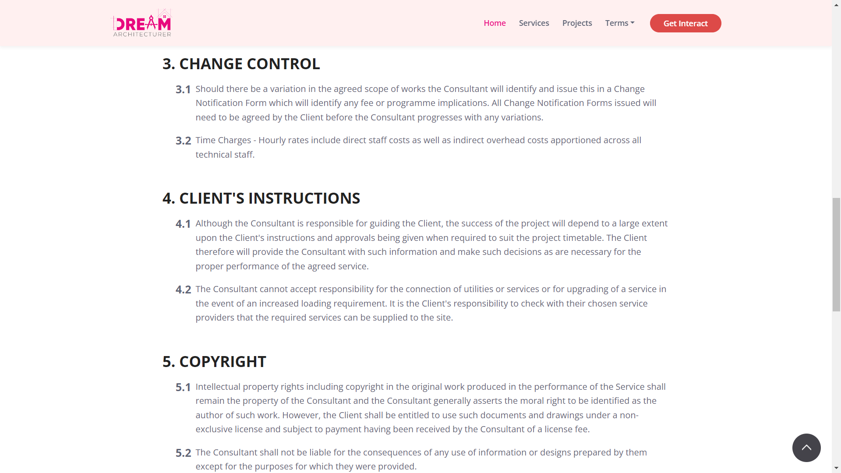

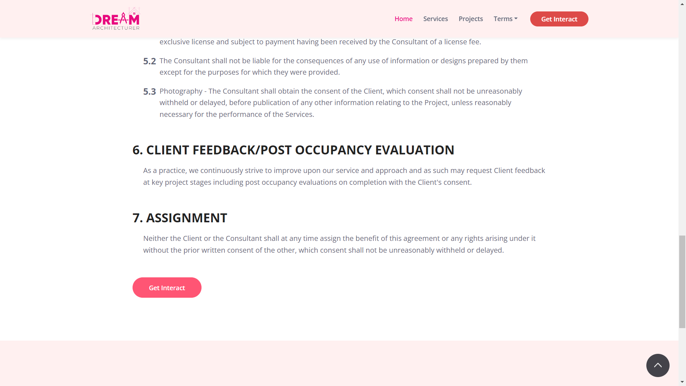

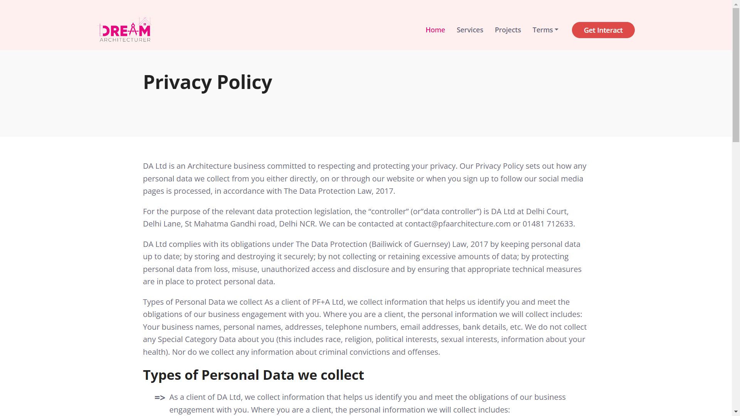

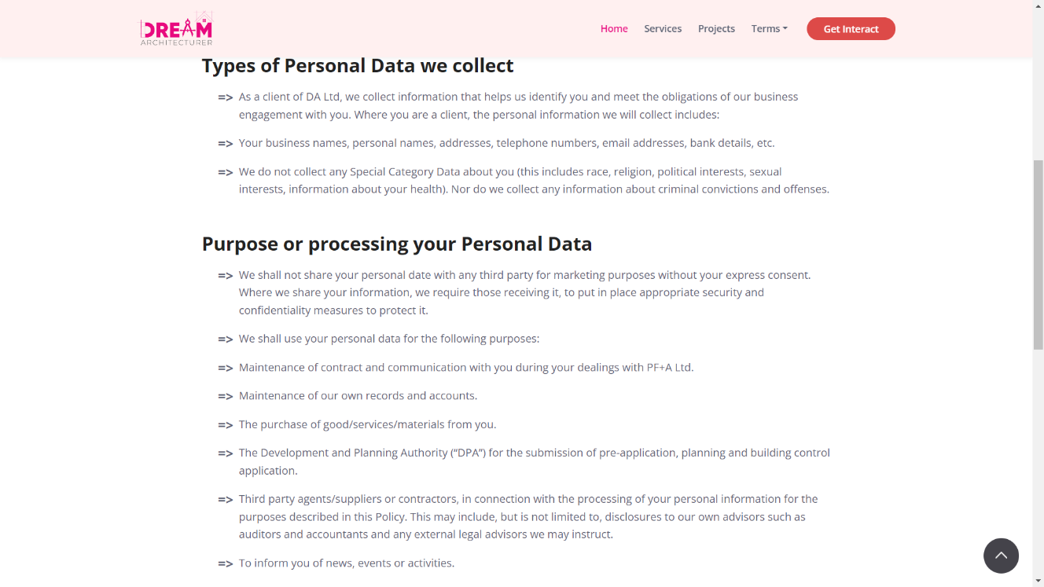

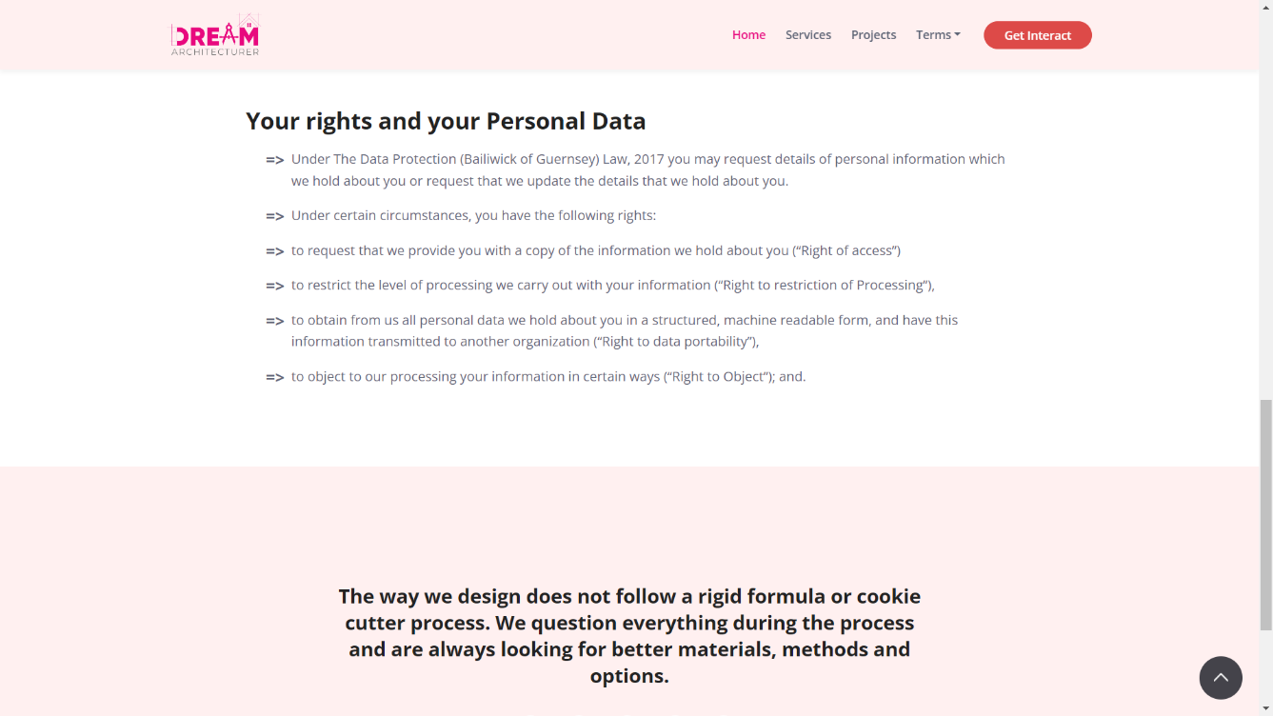

**BACKEND**

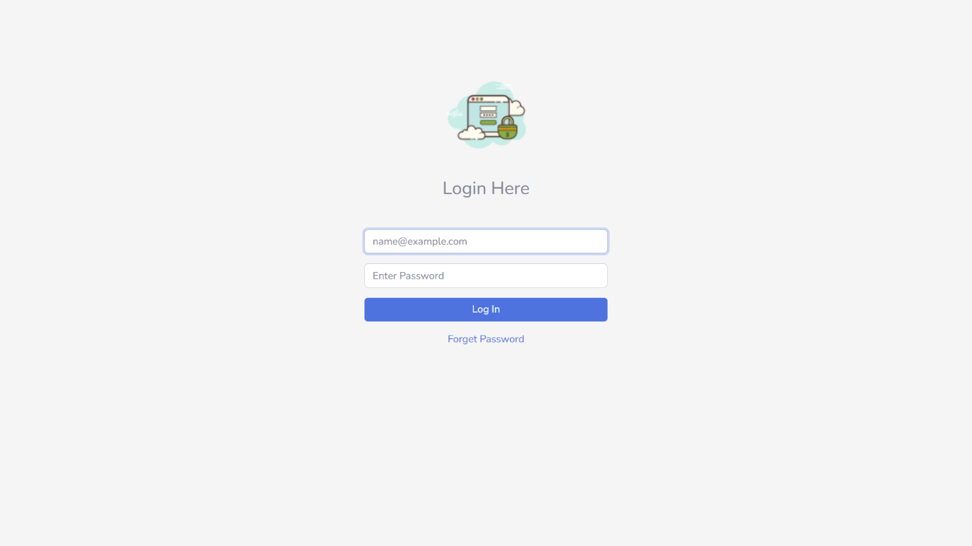

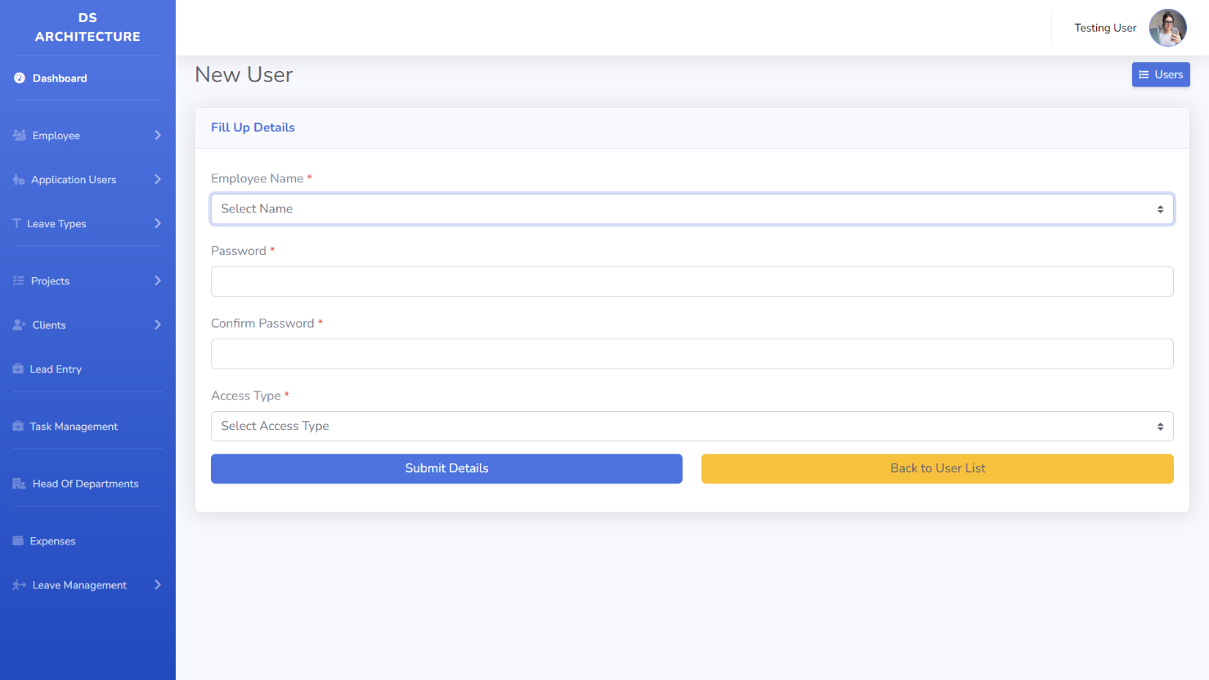

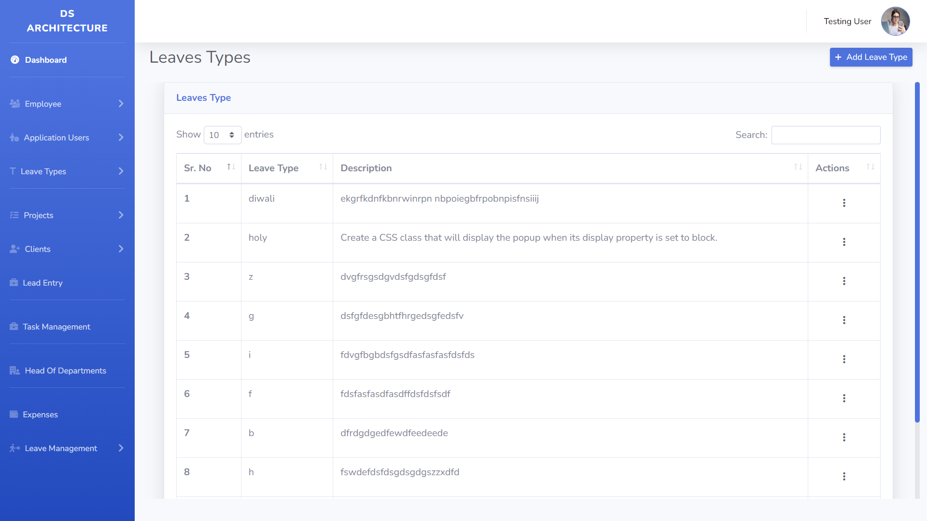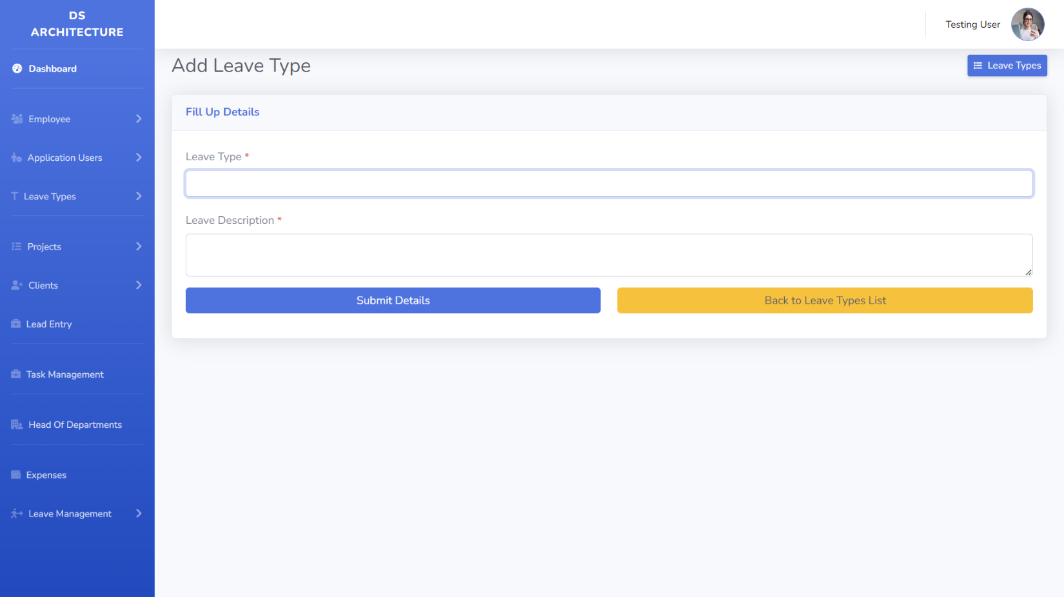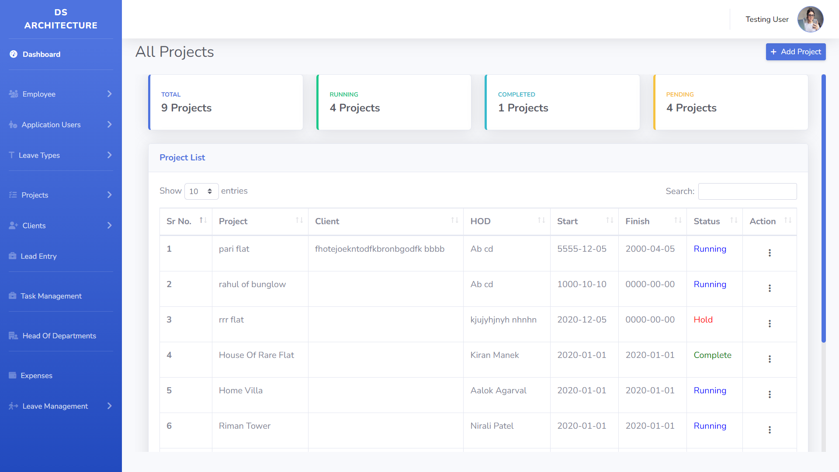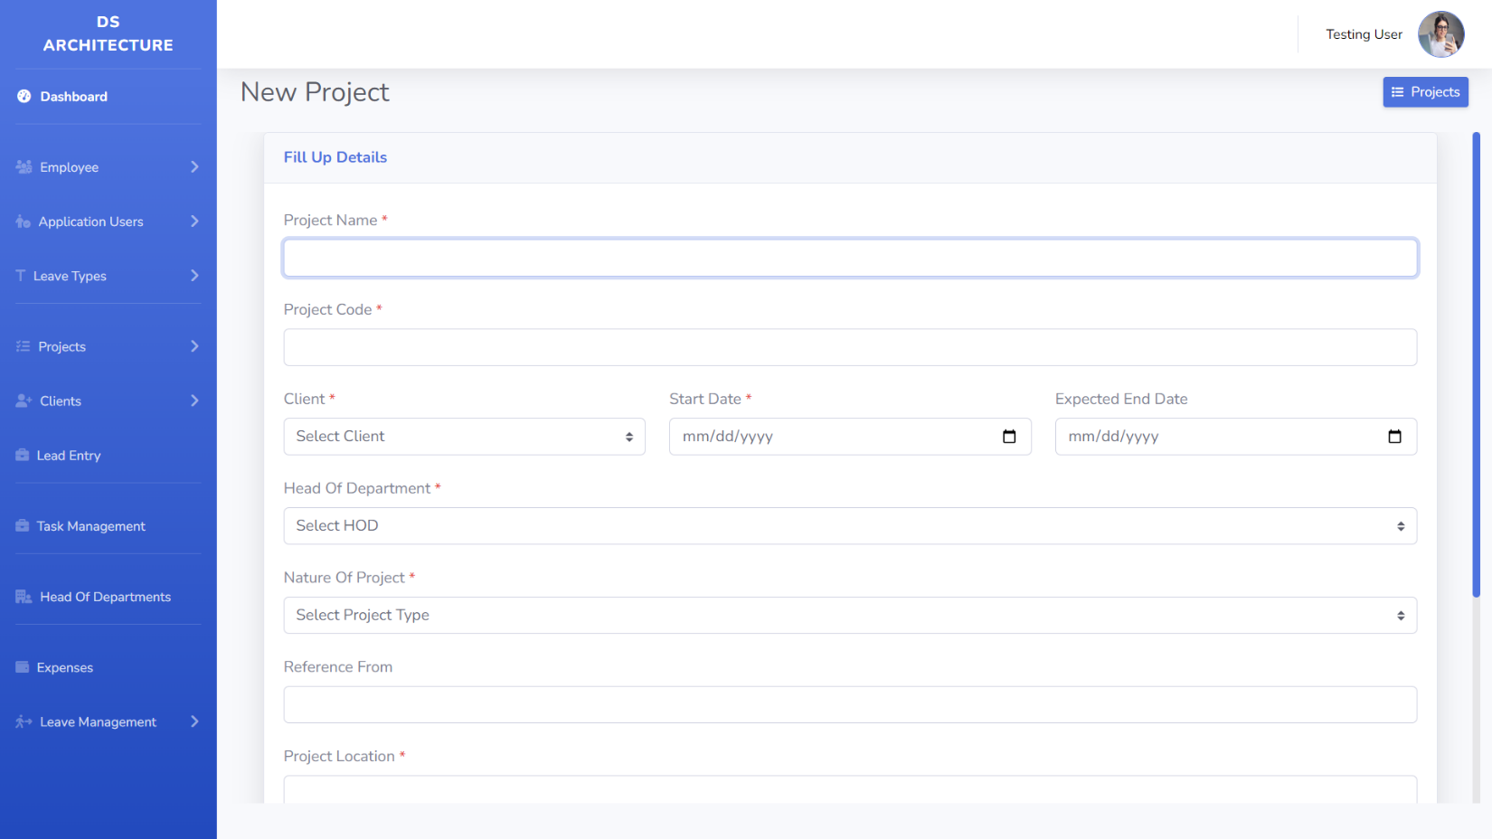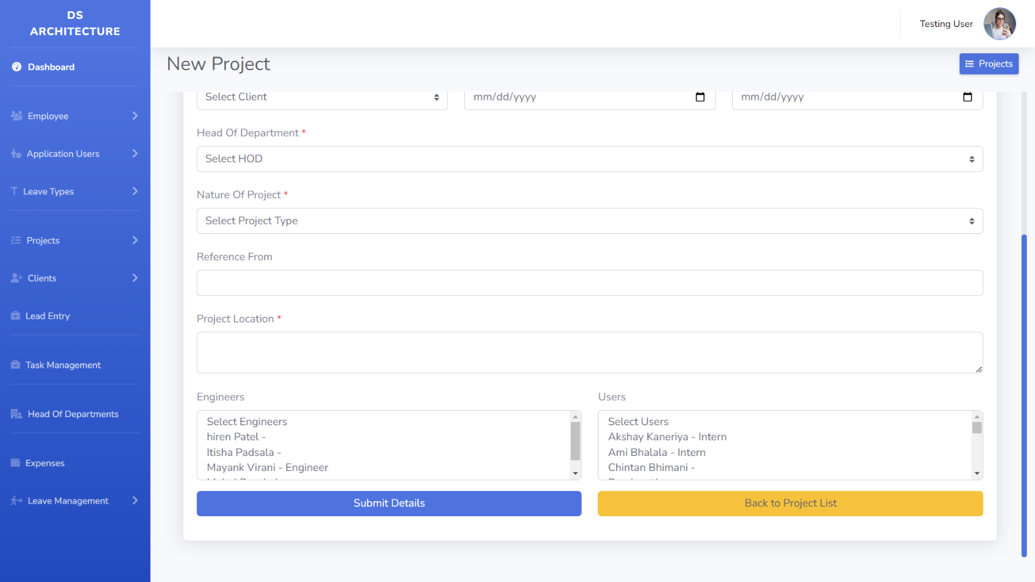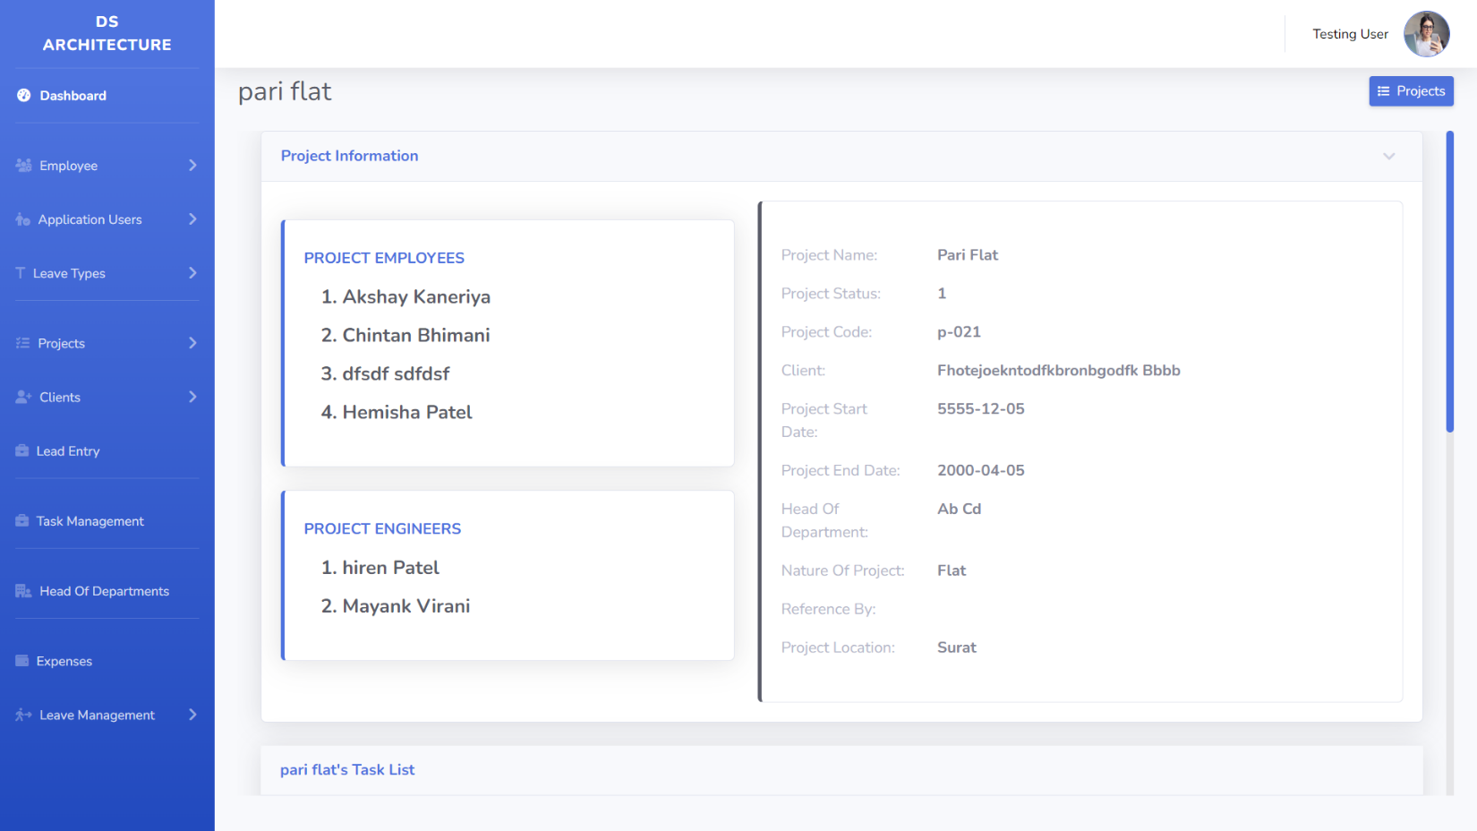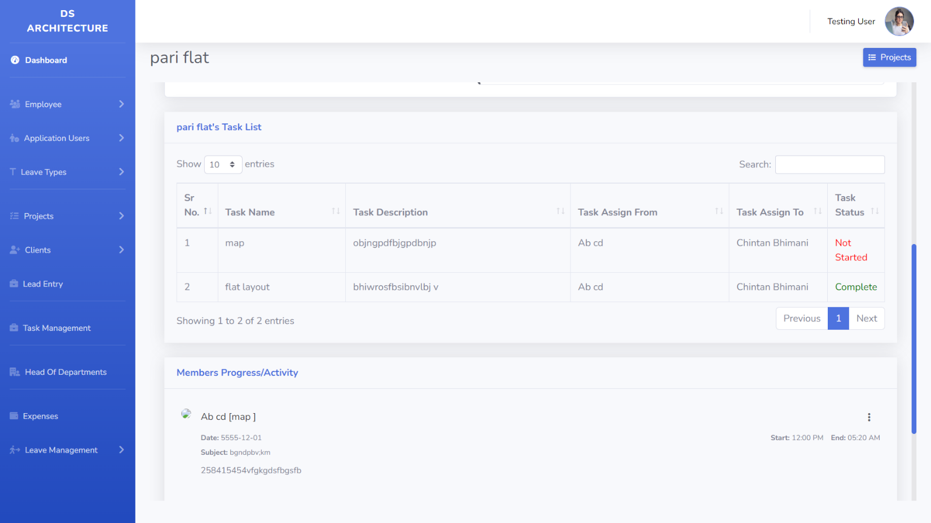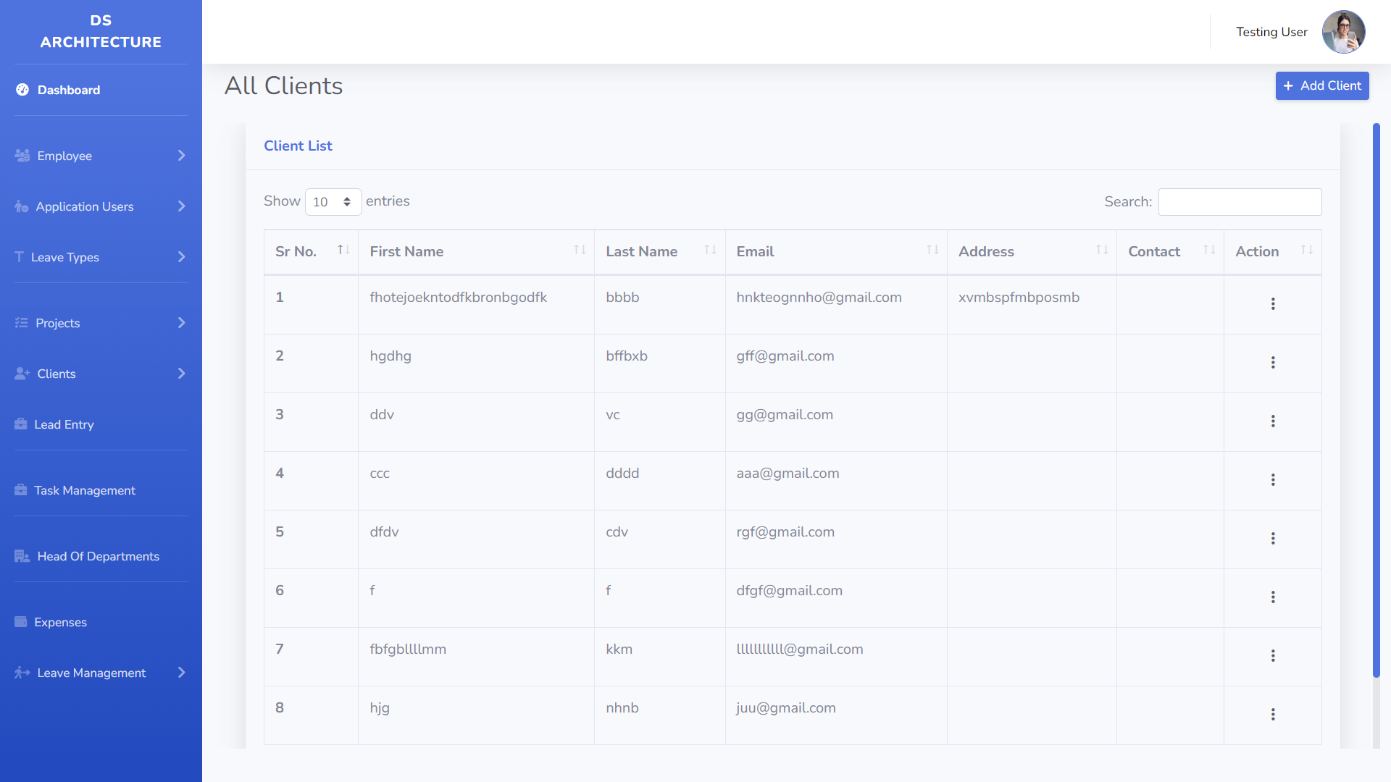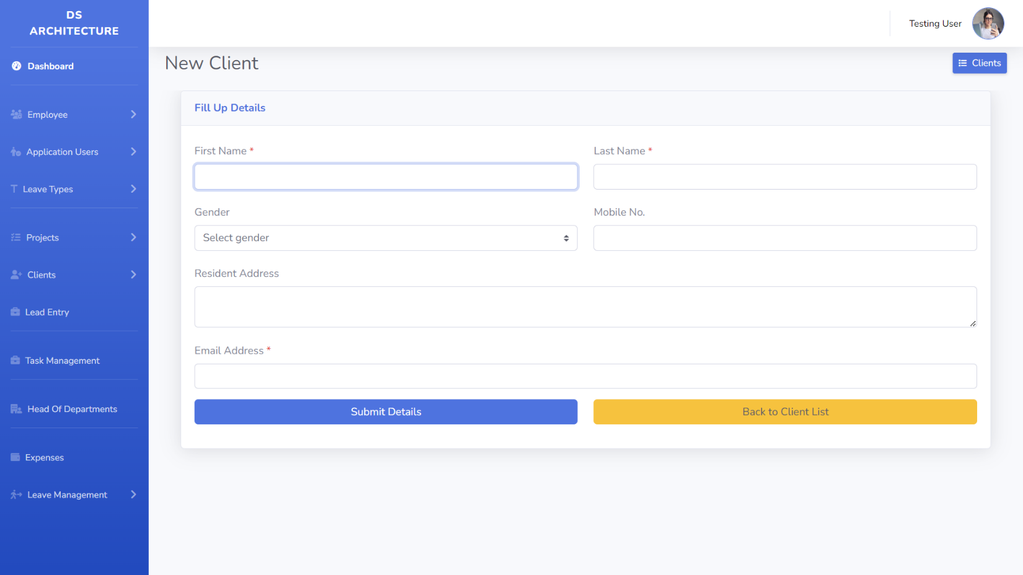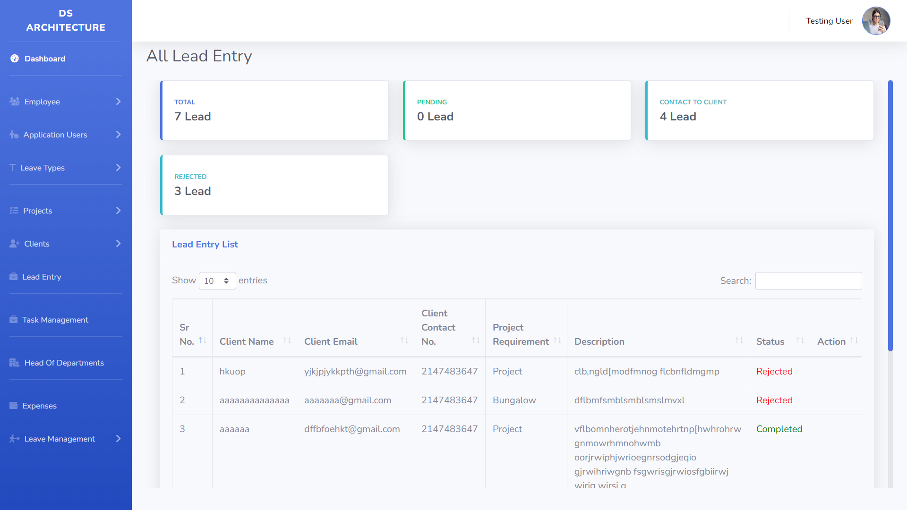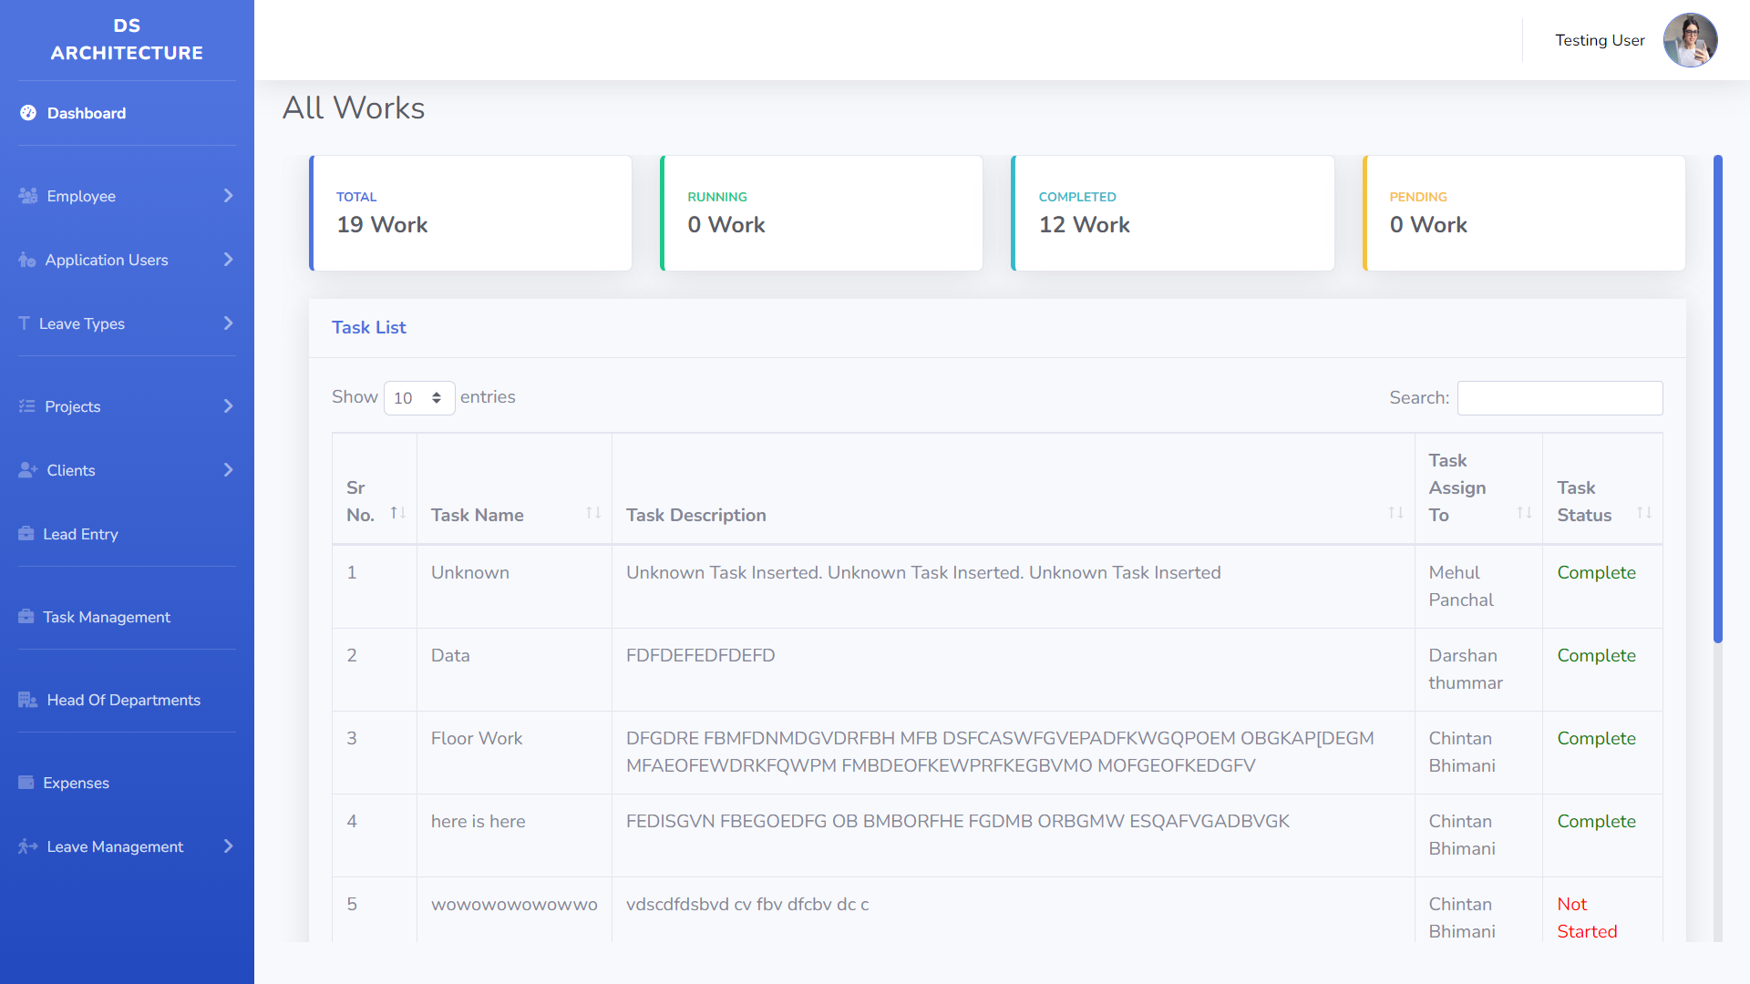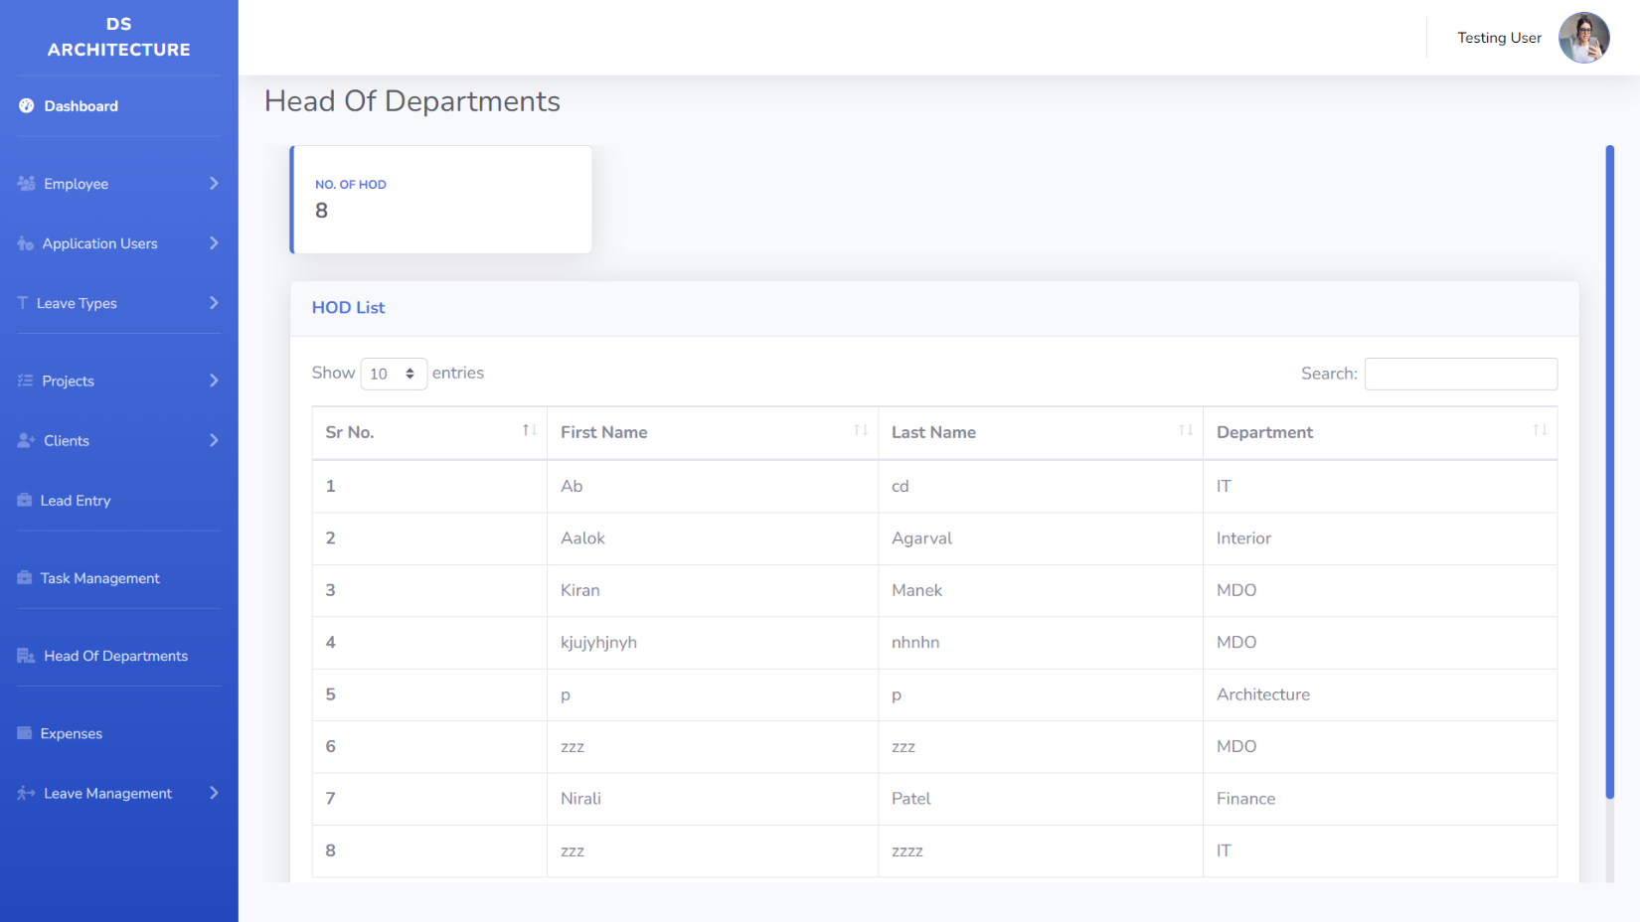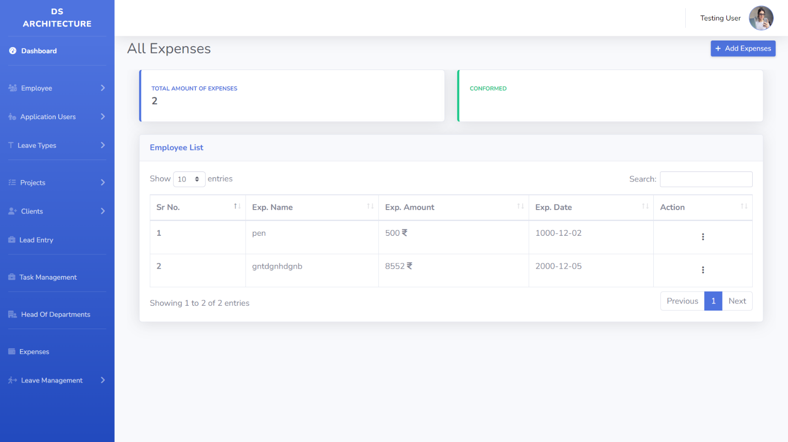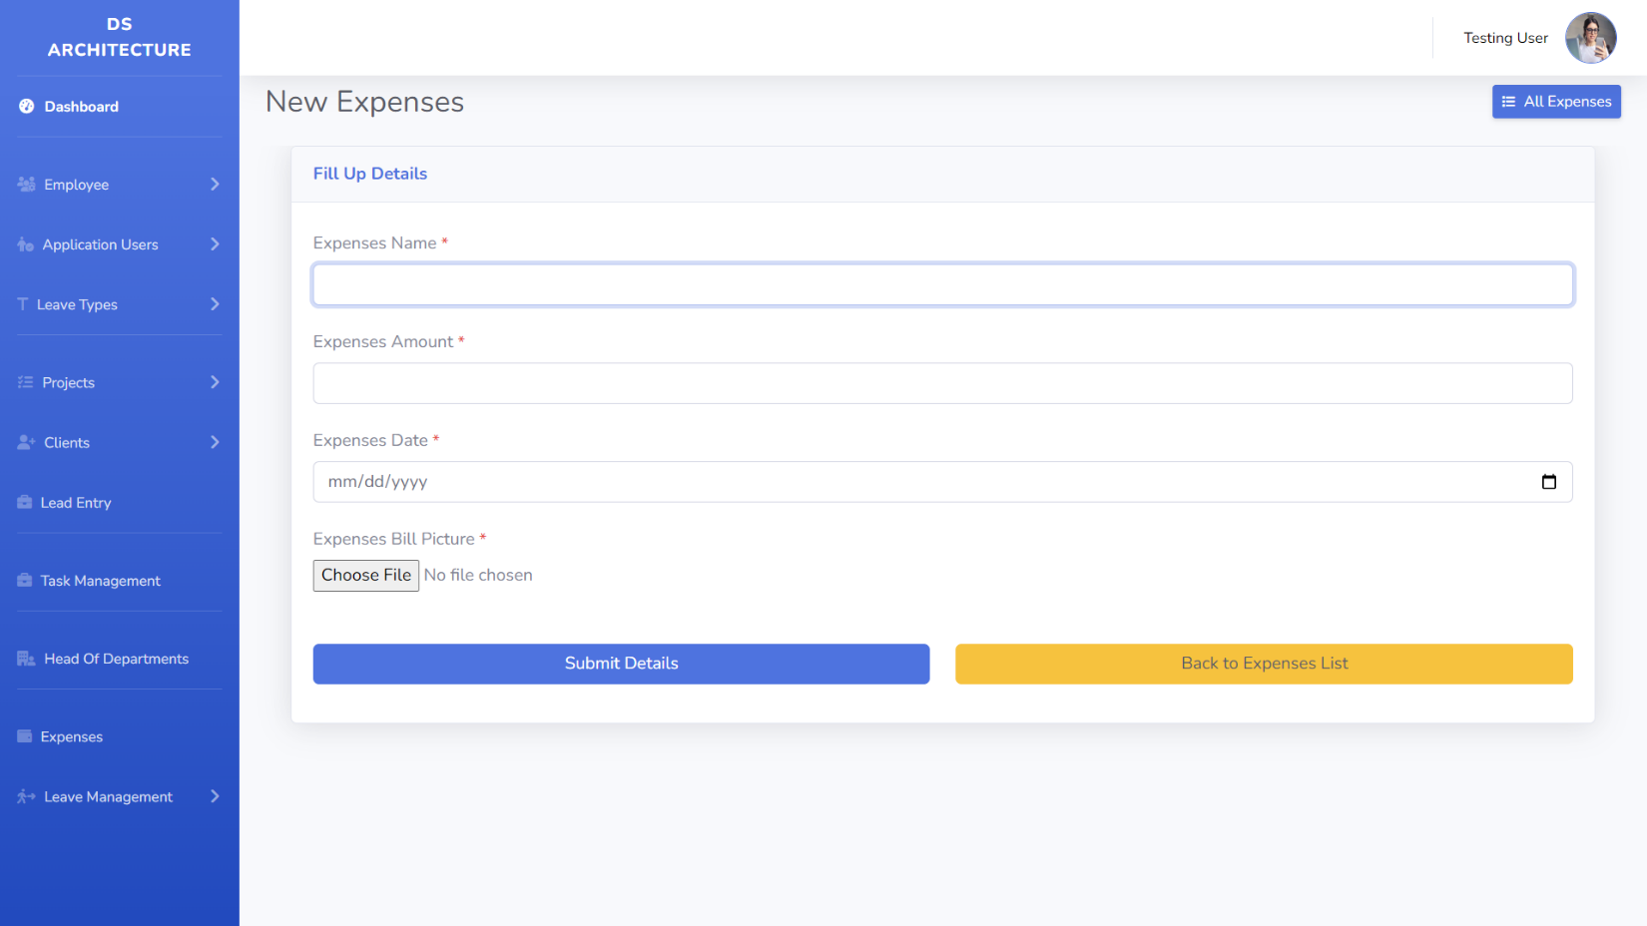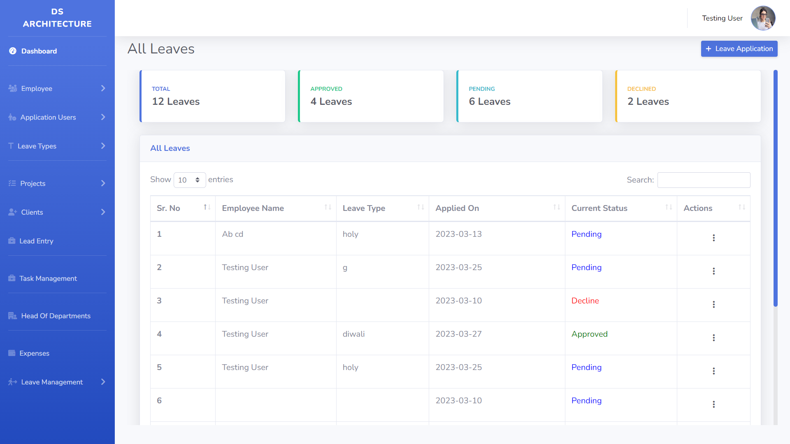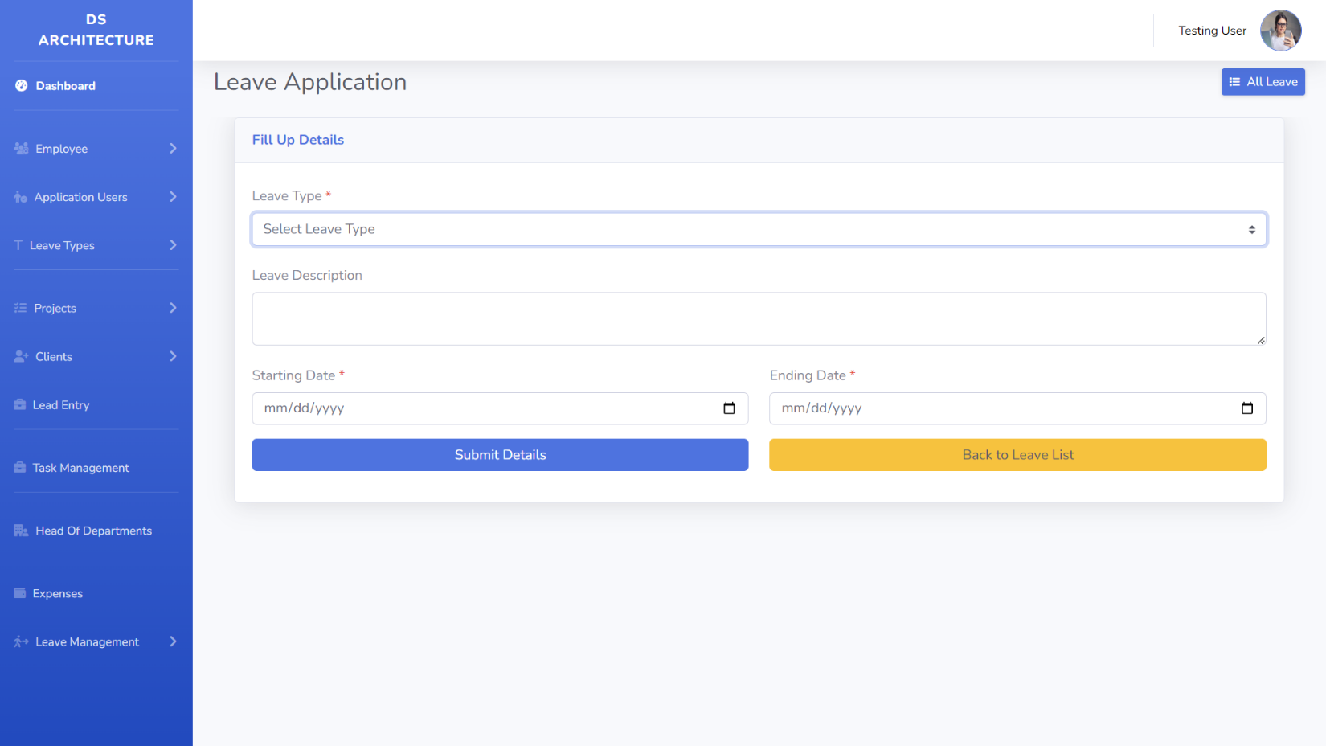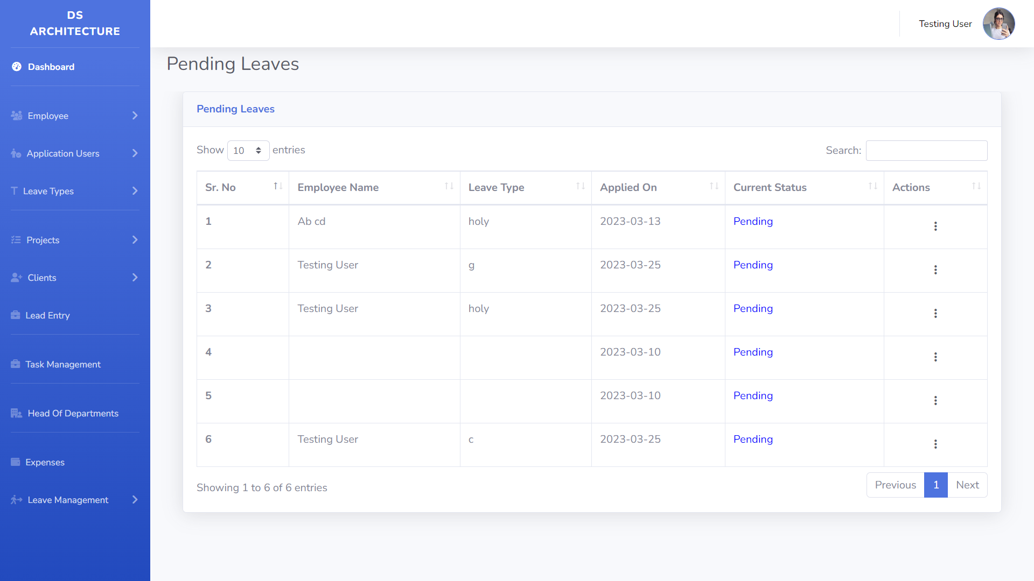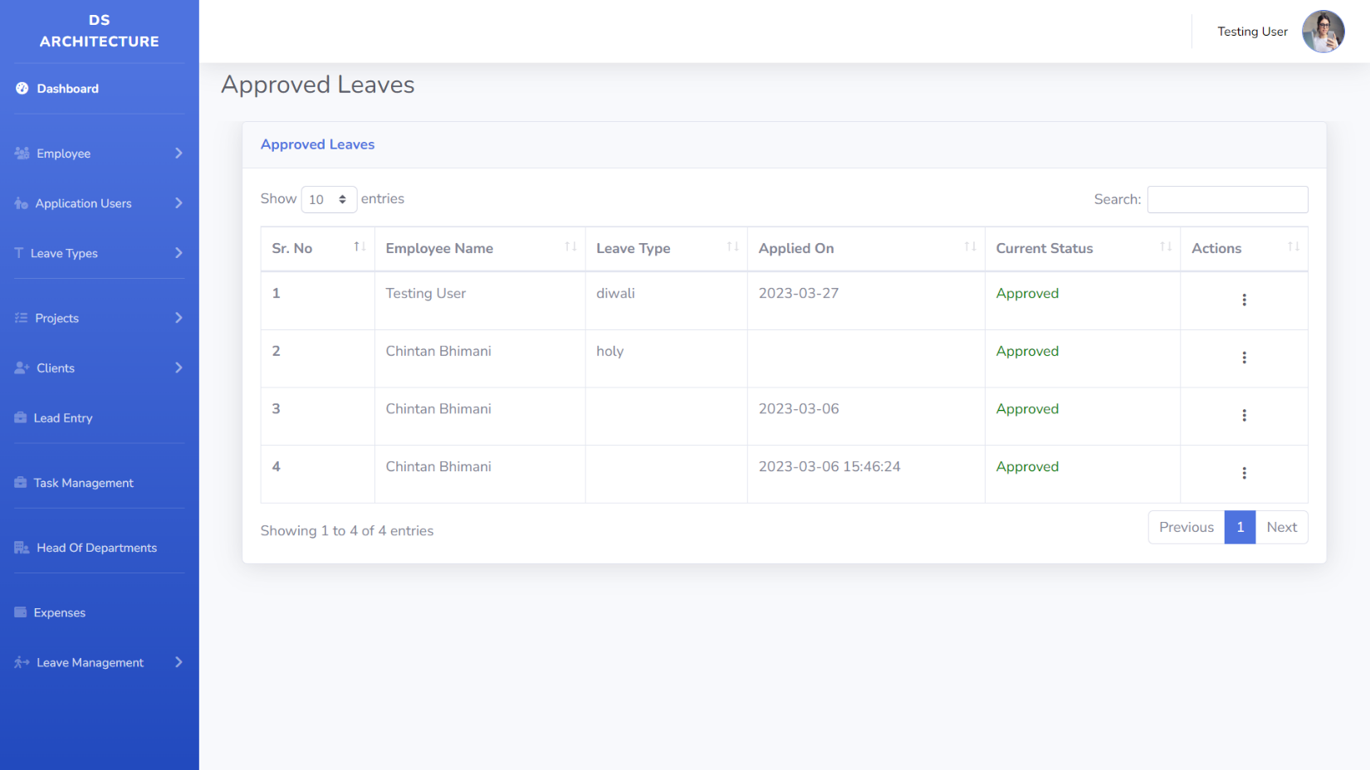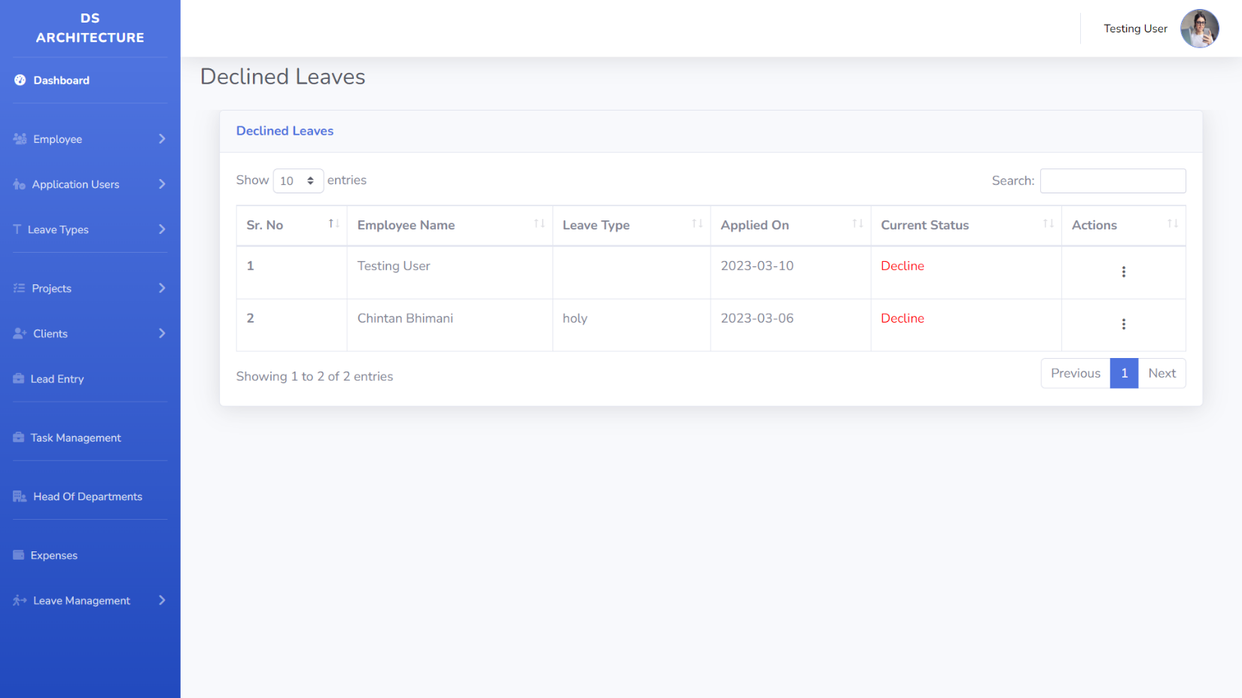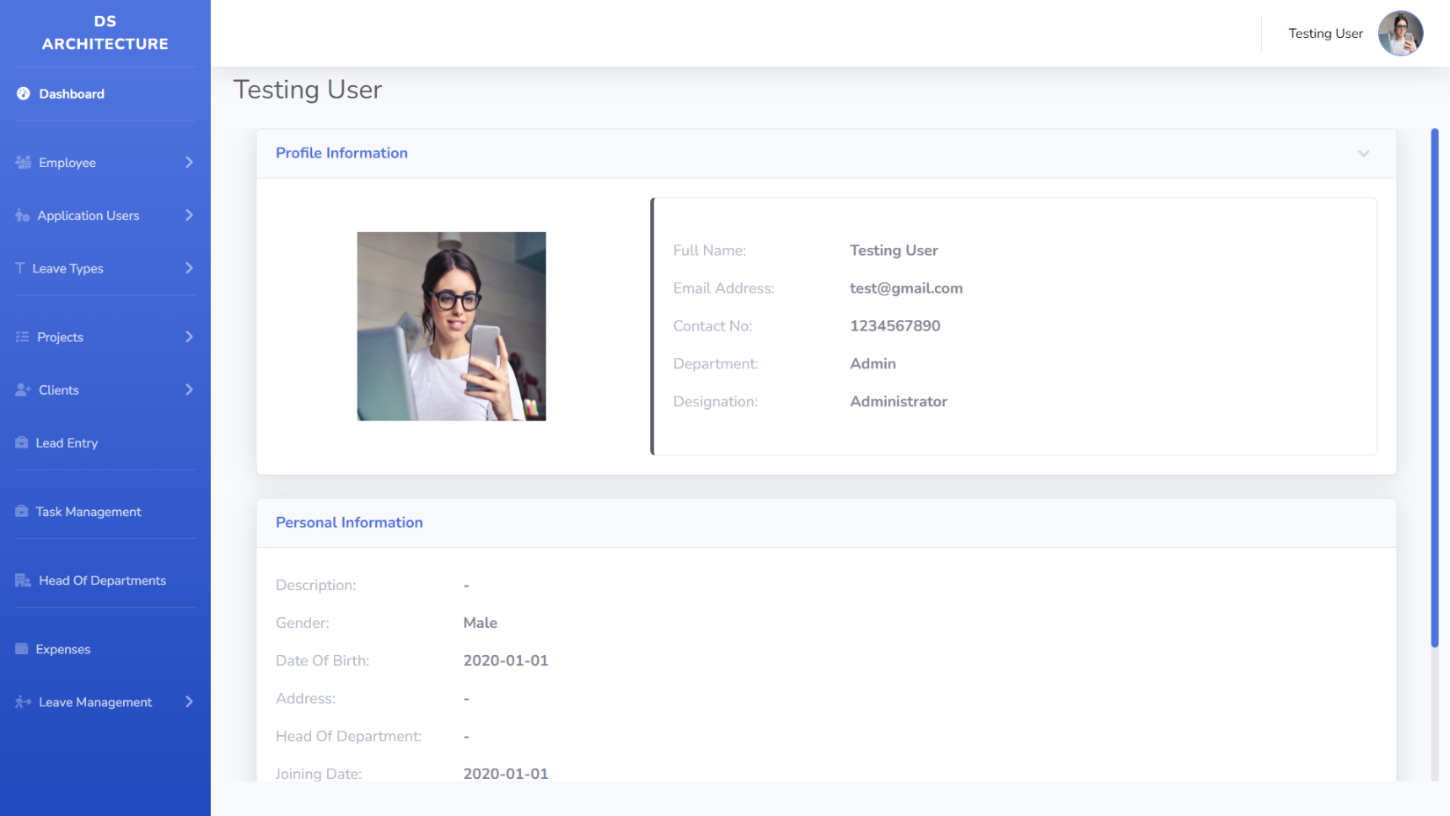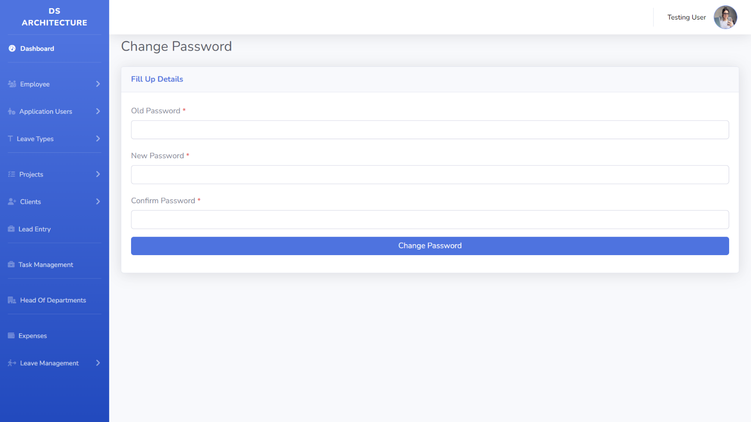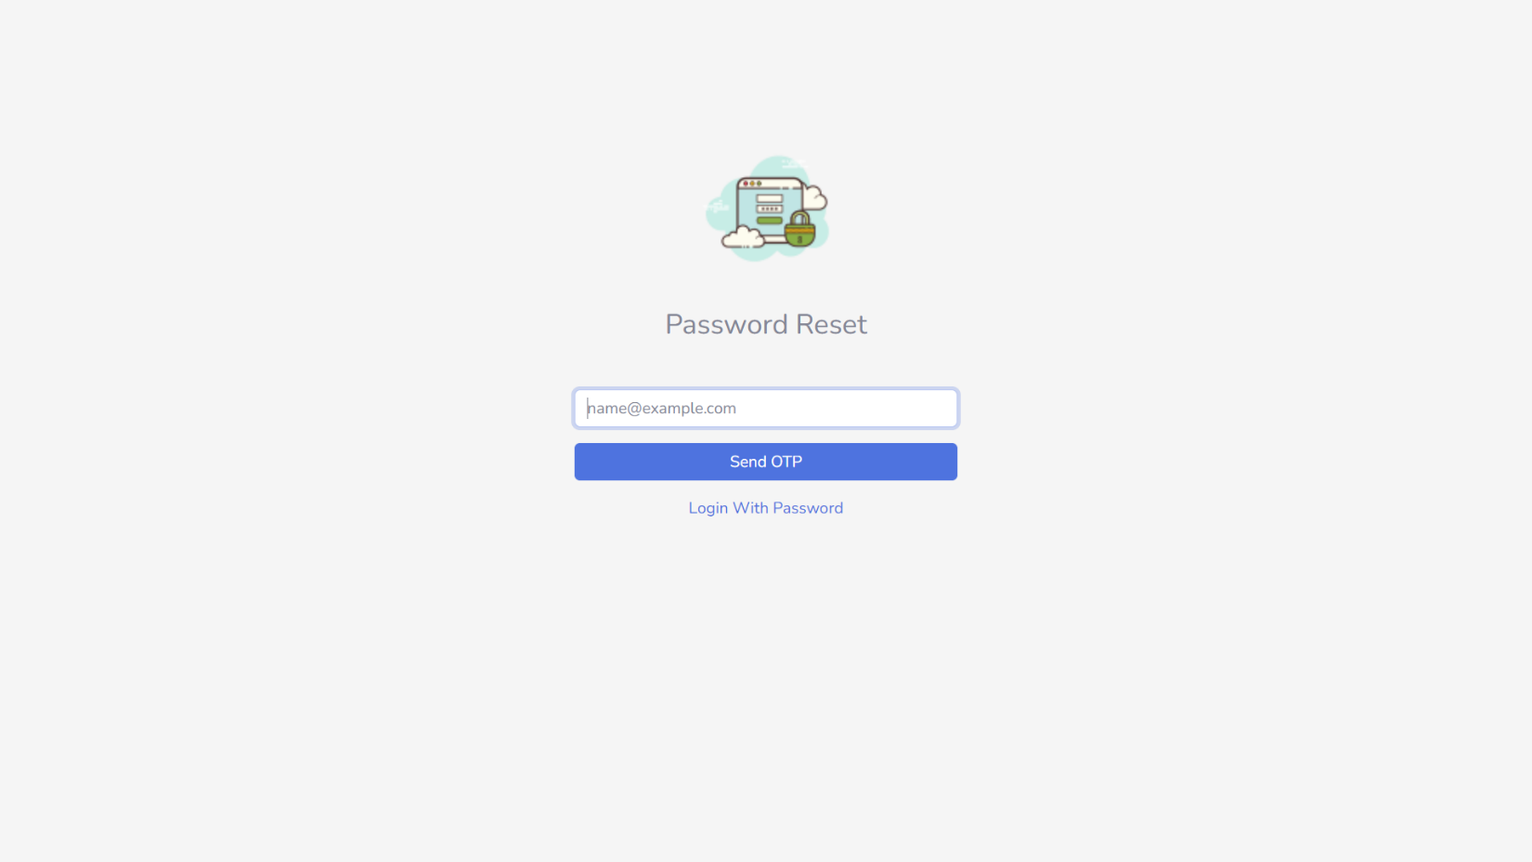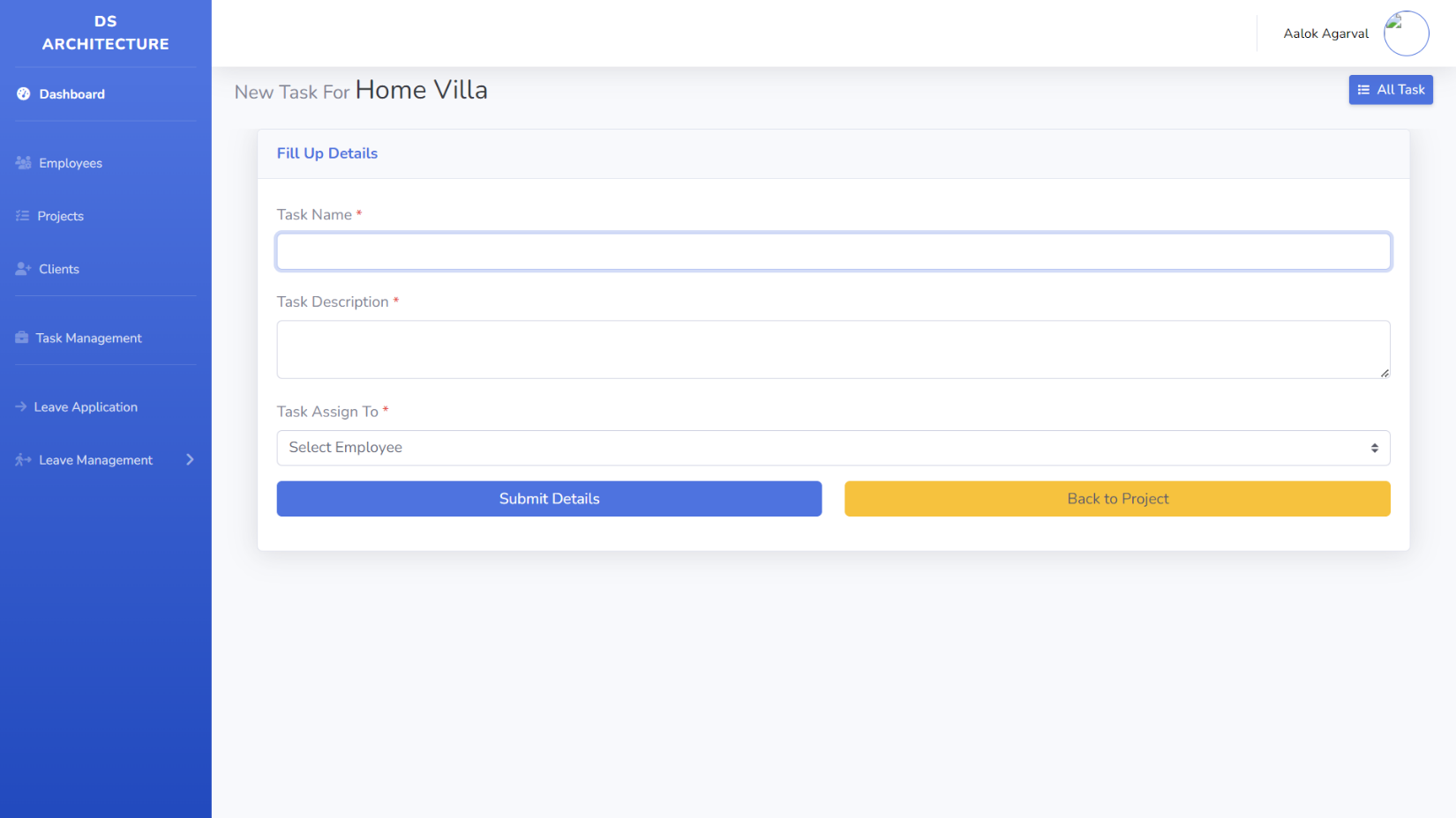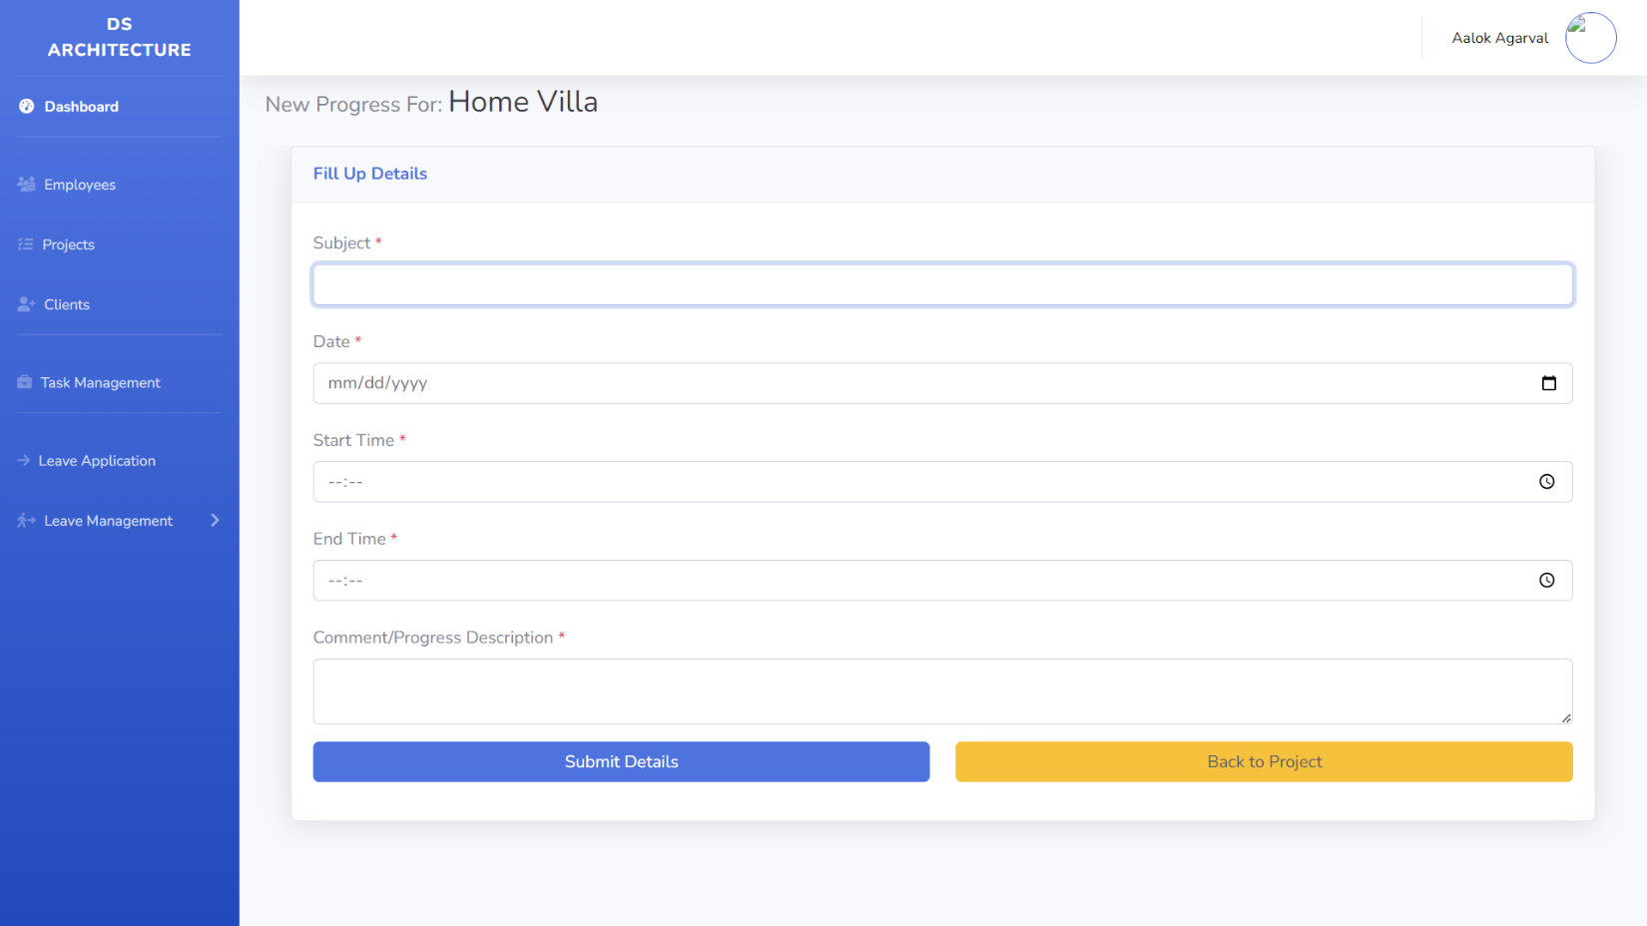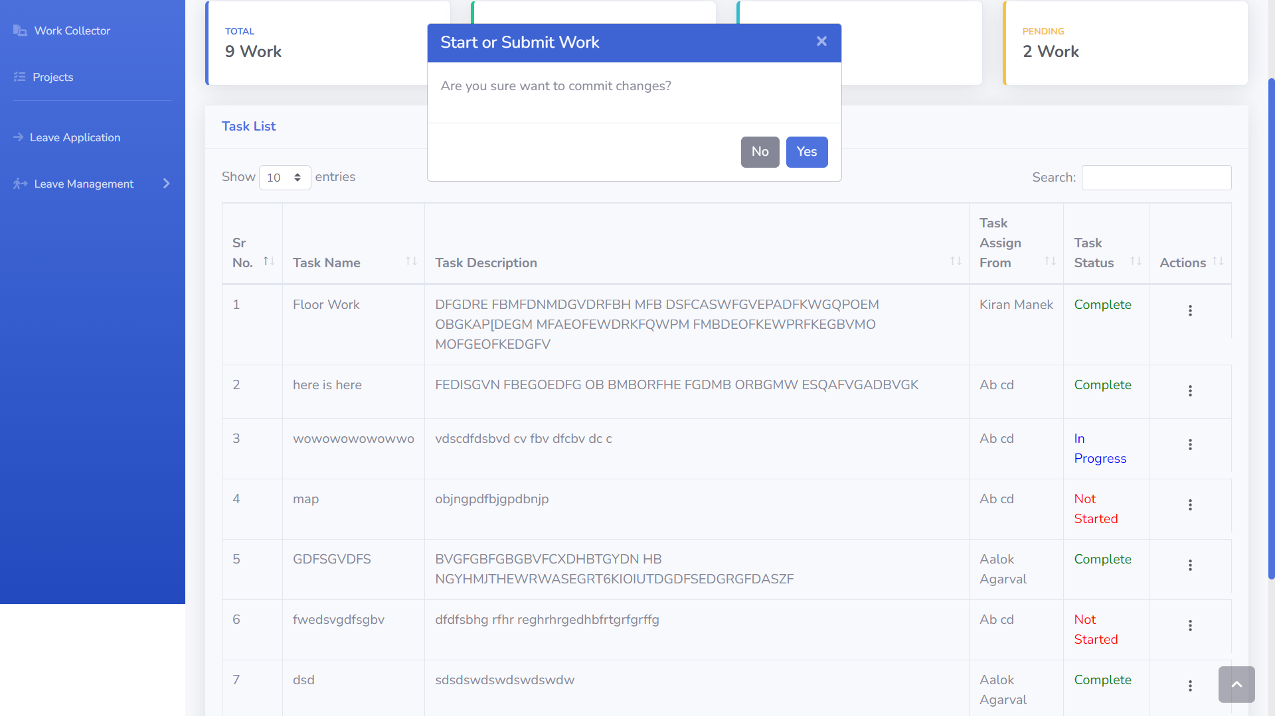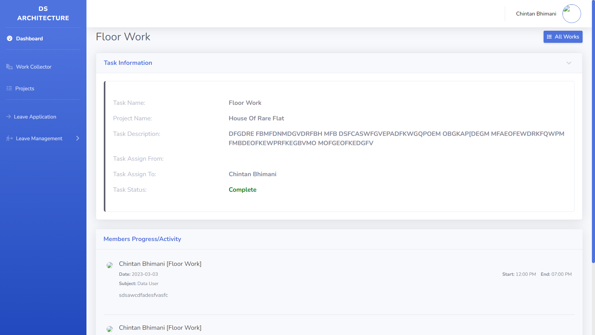

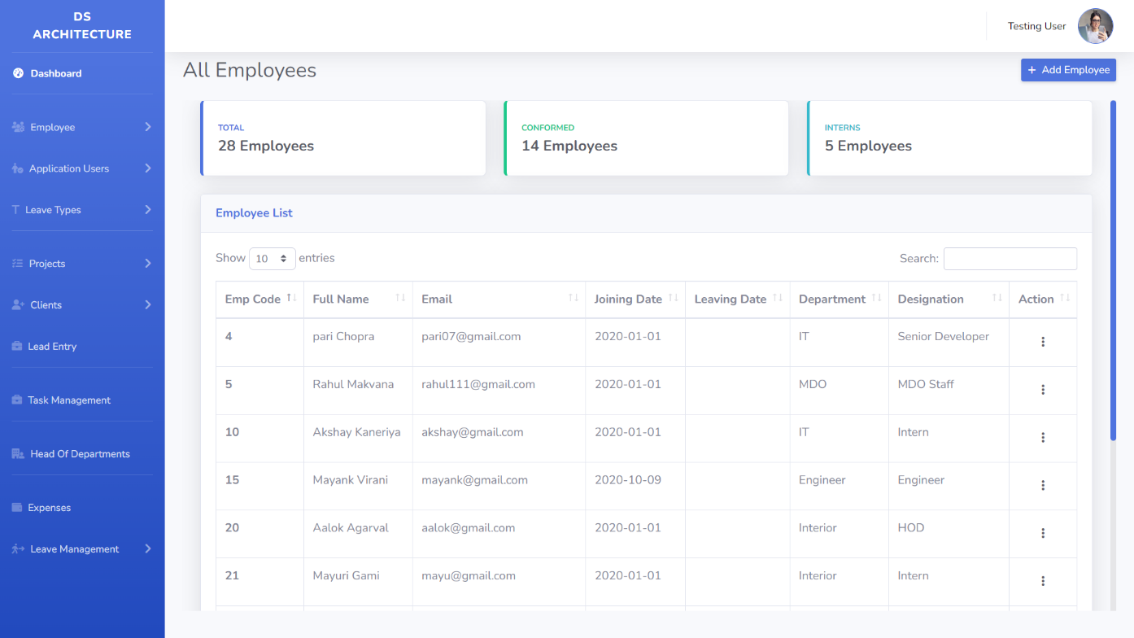

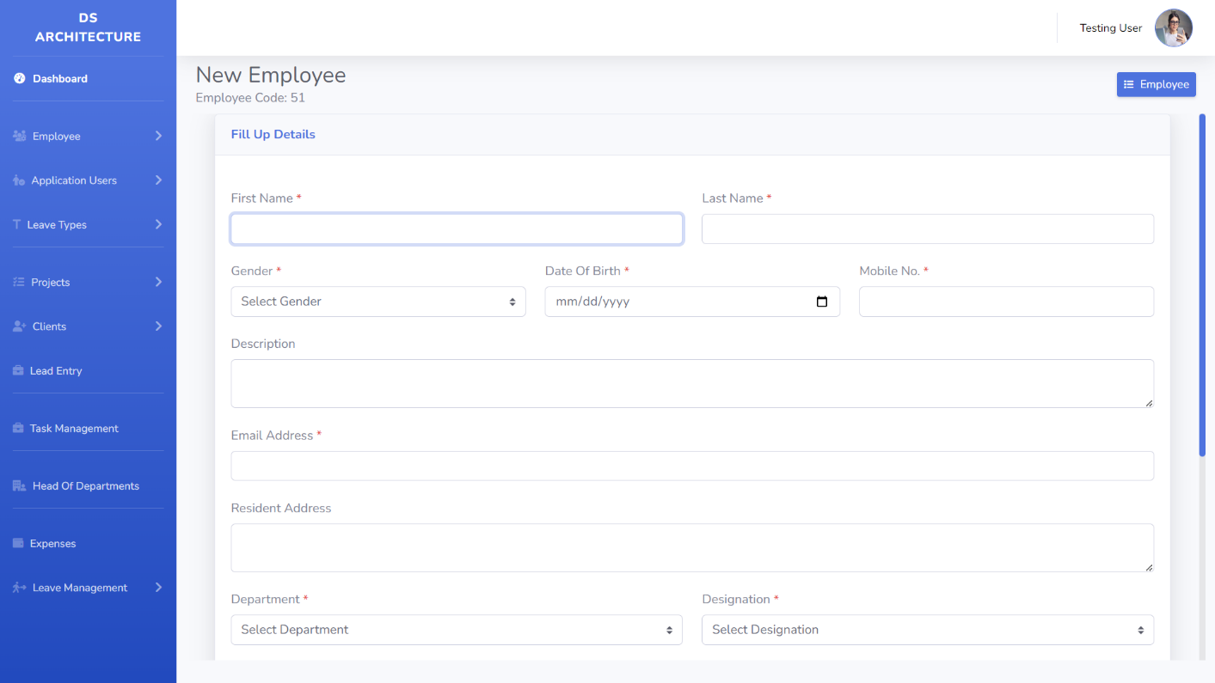

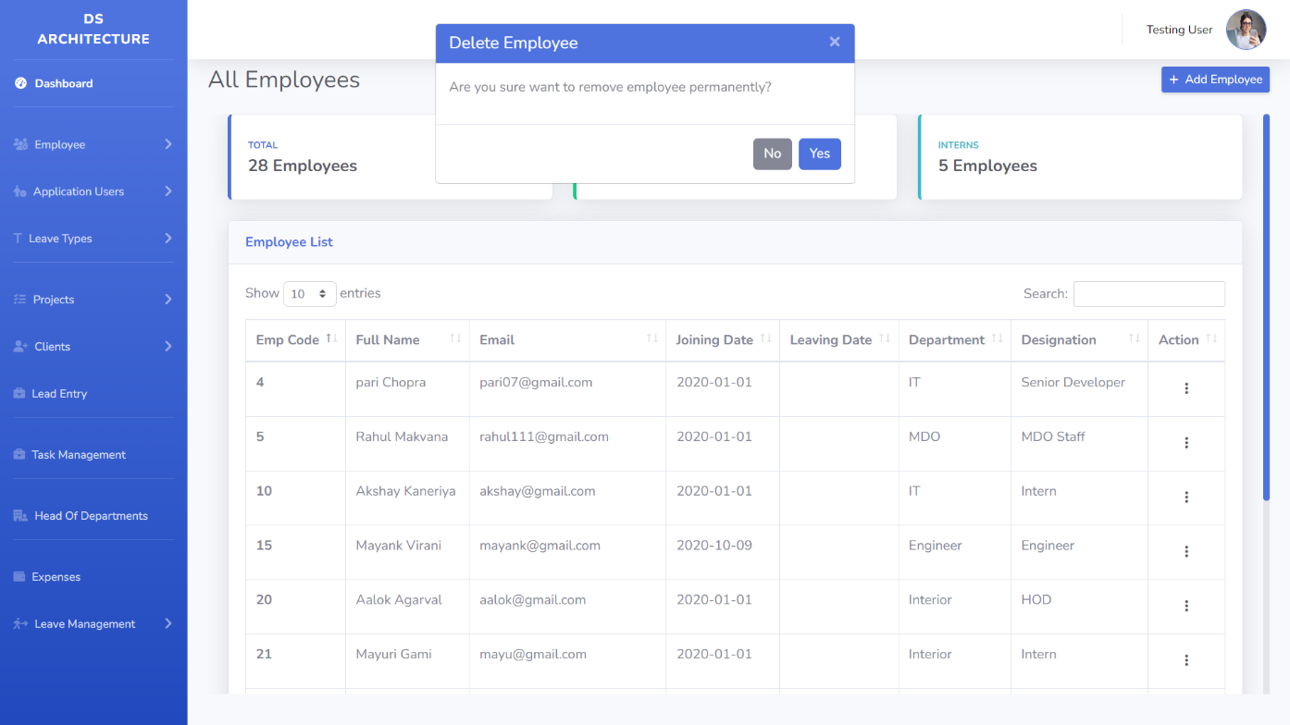

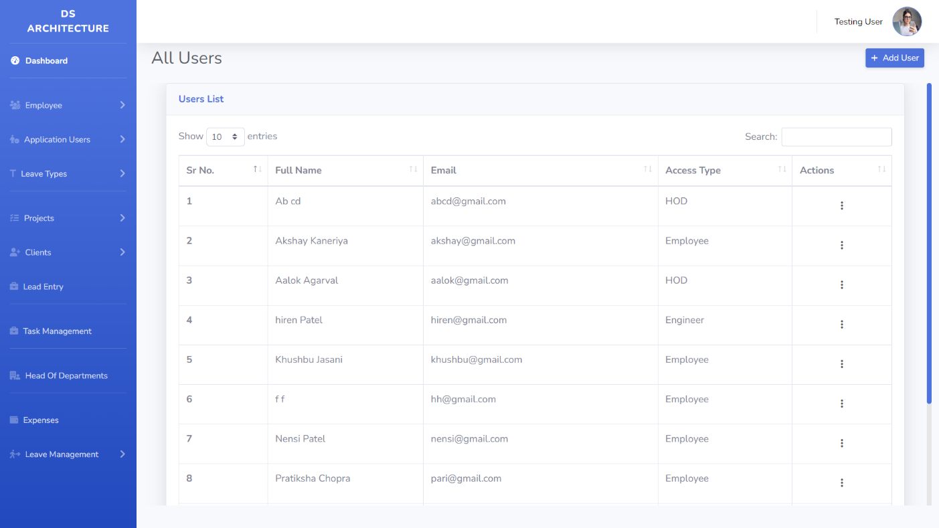

**4. TESTING**

* **Introduction:**

Testing is very important and critical to the success of any project that aims at delivering working software. There are many types of testing that a system may be subjected to, however only the ones in the testing objectives will be carried out for this system.

* **Scope:**

The overall purpose of testing is to ensure the Employee Management System meets all of its functional and business requirements. The purpose of this chapter is to describe the overall test plan and strategy for testing the system.

* **Testing Goals:**

The goals in testing this system include validating the quality, usability, reliability and performance of the application. Testing will be performed from a black-box approach. Tests will be designed around requirements and functionality.

* **Confirmation Testing:**

Confirmation testing or re-testing: When a test fails because of the defect then that defect is reported and a new version of the software is expected that has had the defect fixed. In this case we need to execute the test again to confirm that whether the defect got actually fixed or not. This is known as confirmation testing and also known as re-testing. It is important to ensure that the test is executed in exactly the same way it was the first time using the same inputs, data and environments.

Hence, when the change is made to the defect in order to fix it then confirmation testing or re-testing is helpful.

* **Regression Testing:**

During confirmation testing the defect got fixed and that part of the application started working as intended. But there might be a possibility that the fix may have introduced or uncovered a different defect elsewhere in the software. The way to detect these 'unexpected side-effects' offices is to do regression testing.

The purpose of a regression testing is to verify that modifications in the software or the environment have not caused any unintended adverse side effects and that the system still meets its requirements.

Regression testing are mostly automated because in order to fix the defect the same test is carried out again and again and it will be very tedious to do it manually. Regression tests are executed whenever the software changes, either as a result of fixes or new or changed functionality.

* **Test Plan and Result:**

The Test Plan is derived from the Requirements, Functional Specifications, and detailed Design Specifications. The Test Plan identifies the details of the tests, identifying the associated test case areas within the product.

**4.1 Unit Testing**

|  |  |  |  |  |
| --- | --- | --- | --- | --- |
| Test Case | Test Purpose | Test Condition | Executed Outcome | Actual Result |
| Login | Check Username and password | If user details are not correct, display error message | Grant Access to the application  Main system | User successfully login in to the system upon submission of correct login credentials. |
| Add new Employee | To ensure that a new Employee is added to the system successfully. | If Employee already exists in the system, error message should display. | New employee should be successfully added to the system. | If email address entered already exists in the system, error message is displayed. If the email address of the new employee does not exist in the system, new employee is successfully added. |
| Edit employee details | To ensure that once different details are provided on the edit employee details form and submitted, these details are altered in the database to reflect the recent changes. | On the edit employee details form provide different information from what is currently being displayed. | When the form is altered the details should be altered in the database and a confirmation message of the change should be displayed. | Once the data in the form is altered and the submit button clicked the details in the database are altered and a confirmation message of the change is displayed. |
| Add new User | To ensure that a new User is added to the system successfully. | If User already exists in the system, error message should display. | New User should be successfully added to the system. | If email address entered already exists in the system, error message is displayed. If the email address of the new user does not exist in the system, new user is successfully added. |
| Edit user details | To ensure that once different details are provided on the edit user details form and submitted, these details are altered in the database to reflect the recent chan  ges. | On the edit user details form provide different information from what is currently being displayed. | When the form is altered the details should be altered in the database and a confirmation message of the change should be displayed. | Once the data in the form is altered and the submit button clicked the details in the database are altered and a confirmation message of the change is displayed. |
| Apply leave | To test if all employees can successfully apply for leave | Whenever an employee applies for leave, information as well as attachments should be submitted to the HR manager | Leave request should be sent when all required fields are submitted and necessary documents have been attached to the request | Leave request is submitted as required and a message of success is displayed |
| Create project | Test if a Head of Department can create a project and later assign a project team | Whenever a project is created, HOD should be able to assign project team and view members | A project should be created as well as coming up with a project team and WBS | Project is created and HOD can view the project team |

**4.2 Integration Testing**

Integration testing is any type of software testing that seeks to verify the interfaces between components against a software design. Software components may be integrated in an iterative way or all together ("big bang").

Normally the former is considered a better practice since it allows interface issues to be located more quickly and fixed. Integration testing works to expose defects in the interfaces and interaction between integrated components (modules). Progressively larger groups of tested software components corresponding to elements of the architectural design are integrated and tested until the software works as a system.

**4.3 System Testing**

System testing, or end-to-end testing, tests a completely integrated system to verify that it meets its requirements. For example, a system test might involve testing a logon interface, then creating and editing an entry, plus sending or printing results, followed by summary processing or deletion (or archiving) of entries, then logoff.

In addition, the software testing should ensure that the program, as well as working as expected, does not also destroy or partially corrupt its operating environment or cause other processes within that environment to become inoperative (this includes not corrupting shared memory, not consuming or locking up excessive resources and leaving any parallel processes unharmed by its presence).

**5. CONCLUSION**

The aim of this chapter is to draw conclusions of the work done or achieved and to give an assessment of the completed system, discuss the Problems faced, limitations of the system and give future recommendations on how the system can be improved.

The software product produced was fairly good, it achieved most of the user requirements, the user interface is good and is very easy to navigate, and even novice users can find their way around the web application easily. The client-side validation is excellent. The lack of integration with a payroll system is the major drawback and the system was also unable to generate structured reports i.e., reports based on specific information the Human Resource is interested in.

The biggest challenge faced was getting hold of employee information for Human Resource. The project was initially aimed at implementing an HOD system but that proved to be a challenge because employee information is very critical. This led to the implementation of a generic system thereby drawing a few assumptions were possible meaning that requirements kept on changing as different views were put into consideration as compared to software which has a specific customer.

In the designed system, the HOD can generate a report containing all the employee information from personal profile, skills and educational background. Sometimes, the HOD may be looking for specific employee information e.g., educational background, technical skills or language and location in cases where a transfer is to be made, this poses a challenge because the HR will always have to generate are port of all the information about an employee, some of which may be not be needed.

The head of department creates a project and assigns tasks to a project team therefore he becomes the project manager. This brings about a challenge in cases where a project must be managed by an employee that does not have the role of head of department.

In this chapter, the results were discussed, problems faced and limitations were elaborated. Future recommendations for the extension and improvement of the system have also been discussed as well as well as an assessment of achieved functionality.

**6. BIBLIOGRAPHY & REFERENCES**

* <https://www.udemy.com/course/getting-started-with-php-and-mysql-for-beginners/>
* <https://www.phpclasses.org/>
* <https://phptherightway.com/>
* <https://github.com/>
* <https://jquery.com/>